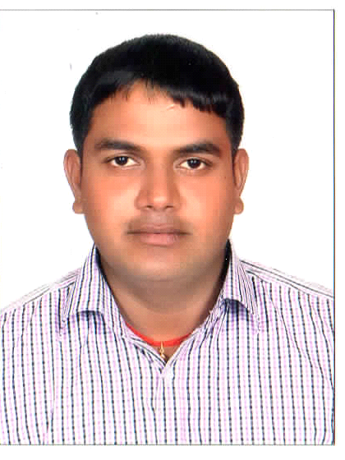
CHANDRAKANT
Abu Dhabi
UAE
C/o 971501685421

Chandrakant.376767@2freemail.com

To prove myself as well trained automobile technician with excellent knowledge base, and ensconce in a reputed automobile company.

SKILL-
Skilled automotive technician, perform maintenance works, identifies resolves auto mechanical and electrical problem for vehicles. Possesses professional capabilities, experience and knowledge.
* Engine, Suspension , Transmission, Brakes, Timing overhaul
and also know AC and Electrical repair.
*Diagnose and solve electrical and mechanical problem.
*Handle computerize diagnostic tools like Tech2 ,GDS, launch x431, Autel Maxisys and manufacturer special scan tools and special tools

SC AUTO CORP. CHEVROLET THANE MUMBAI INDIA.(2yrs)
16-8-2010 to 31-12-2012
Worked as trainee technician for six month and after that worked has technician , And attained a trainings in GM plant in Talegaon Maharashtra India and complete Bronze, Silver and Gold level and a part of that, had attained launch model trainings
AL YOUSUF Motors LLC. UAE
29-01-2013 till 24-09-2017 Working has Automotive Technician

Bright Spark Auto Repairing LLC. UAE
16-10-2017 till 04-1-2018 Working has Automotive Technician

Total exp working has Technician 7 yrs

*Joshi’s Kohinoor Technicial Institute Thane
Vocational Automobile Diploma 2010

MAHARASHTRA STATE BOARD
Secondary School Certificate (SSC) 2008
Good communication skill in English speaking, written and verbal.
Language know as English and hindi

PERSONAL DETAIL—

NAME - Chandrakant

DATE OF BIRTH - 4 october 1990

SEX - Male

NATIONALITY - Indian

CONTACT NO - +971567273848 (UAE)

PASSPROT ISSUSE DATE &PLACE -
08/12/2011 TO 07/12/2021
MUMBAI
DECLARATION -
In the view of the above, I request you to be kind enough to give an opportunity to serve your esteemed organization in the capacity mentioned above, for which act of kindness , I shall very thanks full and great full to you
CHANDRAKANT

