CURRICULUM VITEA

PERSONAL INFORMATION:
PERSONAL INFORMATION
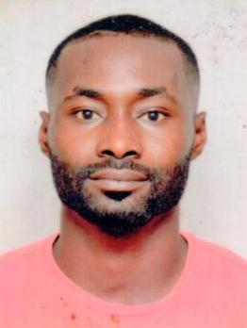
Name : Prince
Date of Birth : 06-05-1987
Visa Status : Tourist visa
Gender : Male
Nationality : Ghana
Marital Status : Single
Email : prince.376785@2freemail.com
C/o-Mobile : +971503718643
Langage : English

POSITION:Bertender,banqueting waiter\resturant waiter.
CAREER OBJECTIVE
To provide myself with more challenging opportunities and to overcome them by honesty, hard work and efficiency to give helping hand for upgrading the reputation & give fame of your organization and for the betterment of self.
Development of my career to a level can meet the needs of the organization as well as my personal needs.

Personal Attribute

  - Good Communication skill.
  - Knowledge of product in a short time
- Highly skilled in serving food, beverages to guests and patrons
- Thorough knowledge of the food, beverages and ingredients
- Well-versed in presenting bill and accepting payment
- Highly skilled in mixing ingredients to prepare potent cocktails
- Ability to work in diverse environments and with diverse groups. Extensive knowledge of hospitality etiquette, food preparation, and customer service training.
- Excellent written and verbal communication skills
WORK EXPERIENCE
- POSITION: Mobile banker
- BRIGHT FUTURE INVESTMENT (2009-2010) Accra-Ghana.

- POSITION : WAITER/BARTENDER
- LA-PALM ROYAL BEACH HOTEL (2010-2012)
ACCRA, GHANA.
Responsibilities

- Provided a warm salutation to guests and accompany them through to the restaurant
- Visit each table day by day basis, ensuring guests are completely satisfied with the food and service
- Direct, oversee and evaluate the performance of hospitality workers
- Notify the Restaurant Manager of any angry patrons
- Welcome customers as they arrive and ask for seating preferences

- POSITION : BARTENDER/BAR SUPERVISOR
- LABADI BEACH HOTEL (2012-2017)
ACCRA,GHANA.
Responsibilities
- Take food and beverage orders and communicate to the kitchen
- Ensure order delivery to the table in a timely manner
- Ensure quantity, quality and accuracy of order
- Set up food stations and tables as directed
- Clean tables and ensure that they are bussed appropriate
- Prepares and serves specialty dishes at tables
- Informs patrons of each day specials.

- ROCKSTONE’S OFFICE(DJANGO BAR/AFTAWERK)),Accra-Ghana<2017.
- POSITION:Head Bartender
- CORAL HOTEL,Emirate mall-Dubai
- POSITION:Kitchen Helper.

Educational Qualification
- Suhum Secondary Technical School (2005-2008)
Course : Business Management / Accounting
Certificate : WASSCE
- Ghana Institute of Management and Public Administration (GIMPA)
Programme : Management in Information System.
Certificate : Diploma in Management System.

DECLARATION

I hereby declare that above mentioned details are correct and complete and best of my knowledge.

