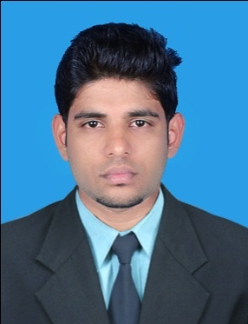
LILLESH

Email : lillesh.376816@2freemail.com

Mob : +971501685421

OBJECTIVE

To contribute to an organization that would offer a challenging job that can add knowledge and skill to achieve professional and personal growth while being resourceful, flexible and innovative.

highlights

- Diploma holder in mechanical engineering with 3 years of experience
- Good communication skill
- Ability to handle manpower
- Ability to rapidly build relationship and set up trust
- Hard Working & Team Player
.

WORK HISTORY

11 . 2016 – 11. 2017 festo india pvt.ltd
diploma enginEer

- Manpower handling
- Ensuring the target based production
- Ensuring the safety of the employees
- Allocating operators in machines
- Gained CNC programming skill

01.2016 – 11. 2016 BNR EXPORTS
DESIGNER (AUTOCAD) cum cnc operator

      - Designing of developing jobs
      - Work experience in CNC Turning

06.2014 – 06.2015 DANA – SPICER INDIA PVT ltd.(jodalli)
operating engineer
Work experience with CNC Machines
Trouble shooting on machines

EDUCATION

2008-2009 GOVT. HIGHER SECONDARY SCHOOL KOROM
SSLC (BOARD OF PUBLIC EDUCATION)
Passed with 85%

2009-2011 NSSMMHSS PAYYANNUR
PLUS TWO (BOARD OF HSE)
Studied with science as main subject
Passed with 78%

2011-2014 MATTANUR GOVT POLYTECHNIC COLLEGE
DIPLOMA (BOARD OF TECHNICAL EXAMINATION KERALA)
Diploma in Mechanical engineering
Did a project on Hydrogen boost engine
Passed with 73.24%

PERSONAL INFORMATION

D O B : 10-06-1993
Language known : English , Hindi , Malayalam , Kannada, Tamil
Nationality : Indian

workstation awareness

- Auto CAD
- MS. Office

DECLARATION

I do hereby declare that the above information is true to the best of my knowledge.

United Arab Emirates Lillesh

