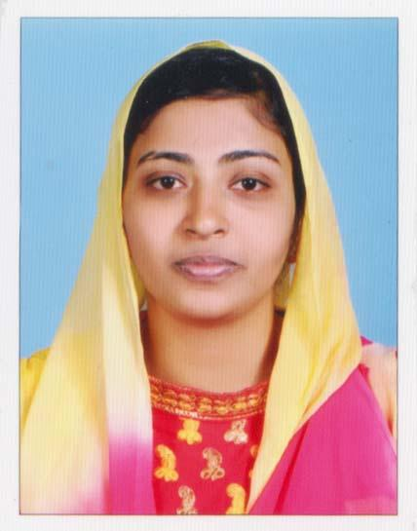

Fathima C/o-Mobile No. : 0502360357

Email: fathima.376819@2freemail.com
CAREER OBJECTIVE
Seeking a suitable opportunity to work in your esteemed organization to contribute my best to the organization and to achieve my career goals.

ACADEMIC OVERVIEW
- 2017 Bachelor of Computer Application from University of Kerala,Kerala,India
- 2017 Dot Net Framework from Information Technology & Innovative Solutions
- 2014 Pre Degree from University of Kerala,India
- 2012 SSLC from University of Kerala,India

COMPUTER PROFICIENCY
- MS Excel,MS Word and Power point
- Photoshop
- Computer Basics
- Well versed with internet

PROFESSIONAL EXPERIENCE
INFORMATION TECHNOLOGY & INNOVATIVE SOLUTIONS,Kollam,Kerala, Training program in .Net Framework from April 2017 to september 2017.

PERSONAL APTITUDE & JOB EXPERTISE
- Strong communication and interpersonal skills.
- Effective time management,prioritisation & work organisation skills.
- Proven leadership qualities with a go-getter attitude.
- Pleasant personality with a mature demeanour.

HOBBIES/INTEREST
- Book Reading
- Singing
- Travelling

PERSONAL MINUTIAE
Date of Birth : 14 SEP 1994
Gender : Female
Nationality : Indian
Marital Status : Married
Languages Known : English,Malayalam and Hindi
Visa Status : Visit Visa
Availability : Immediate

PASSPORT DETAILS
Date of Issue : 13/09/2016
Date of Expiry : 12/09/2026

REFERENCES & DOCUMENTS AVAILABLE ON REQUEST

