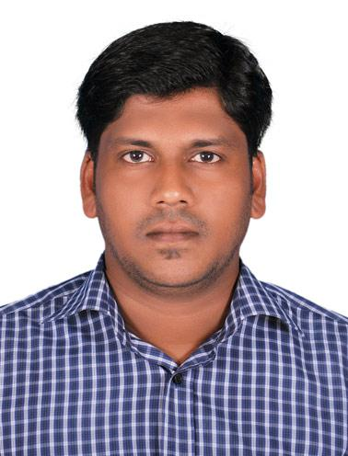
ARAVIND
DUBAI. U.A.E

C/o-Mobile: 0502360357
Email : aravind.376826@2freemail.com
Managing Stores, Sales Consultant, CCTV Technician

Key skills: Experience in How to manage stores,Technical skills & Negotiation skills.

OBJECTIVE

Seeking a challenging career where my abilities can be to great use and where it can be exploited for institutions good and thus paving my future.

Professional Experience

Designation Company Tenure

: CCTV Technician
: MAB International, Al Qusais, Dubai

: April 2013 to Present

Job Responsibilities

- Maintained tools and equipment to ensure good working conditions
- Corrected positions of the CCTV cameras to ensure all angles are covered by the cameras.

- Assured that the machines of the CCTV are in good working condition.

- Changed and replaced cameras that broke down.
- Trained the staff who are assigned to operate the CCTV machines
- Assured that all parts required are available at all times.

PREVIOUS WORK EXPERIENCE

Designation Company Tenure

: Sales Consultant
: Reinhold Wuerth India pvt ltd.

: May 2012 to September 2012

Reinhold Wuerth India Pvt Ltd (Würth group)

World market leader in the trade with connecting materials
The Würth Group is world market leader in its core business, the trade in assembly and fastening material. It currently consists of over 400 companies in more than 80 countries

Duties and Responsibilities:

Promote and sell products to clients and customers. Meet the customer and exceed the needs of the customer. Maintain the contacts and build lasting relationships based on trust andintegrity.

Job Responsibilities

- Selling of General products of Würth

- Maintaining relationship with the Customers
- Handling of customers
- Ensure the Company standards are followed
- Daily reporting to Team Leader.

PREVIOUS WORK EXPERIENCE

Designation Company Tenure

: Store in Charge, Line Inspection (QC Department)
: Industrial Spares Manufacturing and Trading Company (ISMAT), Chennai

: September 2010 to April 2012

Industrial Spares Manufacturing and Trading Company (ISMAT), Chennai

Founded in 1981, ISMAT is now a TIER 1 OEM supplier, catering to diverse clients ranging from manufacturers of earth moving equipments, wind mills to valves & pumps. Lead by a highly experienced team, the firm produces a wide variety of plastic & rubber products using qualitative research techniques and through adoption of industrial best practices.

Job Responsibilities

- Maintaining the stock of raw materials and metal items for ISMAT
- Maintaining the stock ledger
- Making indent for materials

- Making of GRN
- Issuing the Purchase Orders (P.O’s) to the best available supplier
- Follow up with the sub contractors for the delivery as per agreed delivery terms.

EDUCATIONAL QUALIFICATION

Exam / Degree | University / Board | Year and
 |  | Result
BSc Computer Science | Kerala University, India | completed
XII Standard | Board of Higher Secondary | 2004 passed
 | Education Kerala, India
Matriculation | S.S.L.C | 2002 passed

ADDITIONAL QUALIFICATION

- Microsoft Certified Professional (MCP)
- CCNS(CMS certified network specialist) Through CMS computer institute, Kochi
- Diploma in Web Designing (Center for advanced technologies,Pune)
- Oracle (Microtech mavelikkara,affiliated to C-DIT,Govt. of Kerala)

PERSONEL PROFILE
Date of Birth | : | 26-06-1986
Marital Status | : | MARRIED

Computer Skills | : Photoshop, Oracle, Windows, MS-Office & Internet applications
Languages Known | : English, Hindi, Malayalam and Tamil
PASSPORT DETAILS
Date of Issue | : 03-02-2009
Place of Issue | : COCHIN
Date of Expiry | : 02-02-2019
Visa | : Residence Visa
REFERENCE

Furnish promptly upon request with supporting documents

DECLARATION

I here declare that all information furnished above is true

ARAVIND

