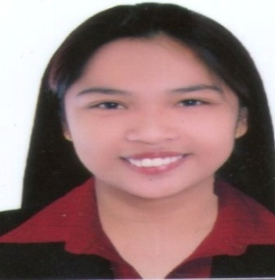
MARIA
Email : mauri.376832@2freemail.com
Mobile : +971505891826

PROFESSIONAL EXPERIENCE

Customer Support Representatives
Hewlett Packard Enterprise / DXC Technology Mckinley Hill , Philippines
March 13, 2017 to December 22, 2017

Job Description:
- Interact with customers via inbound telephone calls to provide information and assistance.
- Achieve productivity standards and goals while maintaining the highest level of customer service
- Process transactions and reply to inquiries about products and services
- Achieve productivity standards and goals while maintaining the highest level of customer service
- Process transactions and reply to inquiries about products and services
- customer interactions, details of inquiries, complaints or comments as well as actions taken.
- Use computer system to track, gather information, and/or troubleshoot customer issues.
- Refer unresolved customer issues to designated department for solution.
Sales Assistant
Liwa Trading Enterprise L.L.C - Disney Fashion/ Collezione / M& Co./ Lovisa Abu Dhabi , UAE
November 14,2014 to November 14,2016

Job Description:
- Responsible for liaising with customers in order to maintain a high level of customer service
- Help customers choose between the company’s array of goods and services.
- Providing customers with information on pricing and product availability.
- Process payments
- Ensuring stock levels are well maintained.
- Calculate total payments received during a time period, and reconcile this with total sales.
- Process merchandise returns and exchange.

Data Encoder – OJT
MITD, Budget Office Baguio City , Philippines
April 2013-May 2013

Job Description:
- Create the Pivot Table and Pivot charts of Financial Statements using Microsoft excel.
- Database Design (General Services Office (GSO) Forms)
- Create Data Dictionary (GSO Forms)
- Gathered Data for the Employees

Data Encoder – OJT
Nueva Ecija Electric Cooperative Nueva Ecija Philippines
April 2012-May 2012

Job Description:
- Assist NEECO Consumers to update their information records.
- Find NEECO Consumers Account Numbers and Account Names.
- List NEECO Consumers complaints.
- Print Reconnection Notice.

SKILLS:

- Computer Literate
- Proficient in Microsoft Office
- Word
- Excel
- PowerPoint
- Knowledge in Database, Websites, Structured Query Language, PHP, Photoshop, HTML,Visual Basic.
- Keen to details

EDUCATION:
Nueva Ecija University of Science and Technology
Bachelor of Science in Information Technology (BSIT)
Major in Programming

SEMINARS:

- Virtualization of Data Centers (Subic Bay, Olongapo City)
- Mindsets of Successful IT Professionals (Sumacab Este, Cabanatuan City)
- Pre-Employment Orientation Seminar (General Tinio, Cabanatuan City)

References available upon request.

