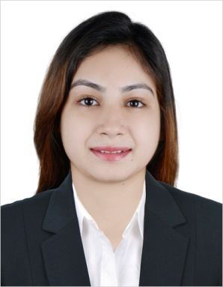
Full Name Ribca

Position applied for Customer Services

E-Mail ribca.376855@2freemail.com

C/o-Mobile +971505891826

Objective
To work in and organization /industry will provide learning and growth opportunities in the relevant work through daily challenges. I want to work and build my career to earn my livelihood but also gain vast number of opportunities to learn, grow and be an added value to the organization if i have my selection for any suitable job
Professional Experience
Employer | Position | Duration
Holiday Inn Bur Dubai Hotel | Telephone Operator | 20th August 2015 from 20th August 2017.
PC pearl continental Hotel Peshawar | Telephone Operator | 1Year
Telenor telecommunication office | Customer service | 10 months

Duties and Responsibilities
- Answer telephone calls and provide information to callers.
- Arranging appointments
- Greet persons entering the office.
- Ensure knowledge of staff movements in and out of organization.
- Monitor visitor’s access and maintain security awareness.
- Control inventory relevant to reception area.
- Kept all the staff files.
- Resolved costumer problems.
- Update about daily promotion packages.
- Making files and documentations.
- Sending passports to CID.
- Scanning the passports of the Guests.
- Making the keys for the guest rooms.
- Giving reminder wakeup calls to Guests.
- Keeping all the records of pre authorisation.
- Maintaining the high standard for the property.

Professional Qualification
Institutes | Degree | Grade | Passing Year
Jinnah international degree college Peshawar | B.A  (Statistics, Economics, English, Pak Studies ) | 297/ B | September 2014
Jinnah international degree College Peshawar | F. SC  (Computer Science, Economics, Statistics) | 692/ B | April 2012
Presentation Convent High School Peshawar | Matric (Computer Science) | 766/ A | April 2009

Professional Achievements
- Computer course in MS- Office, Power Point, Excel and Word. From Jinnah International Degree College
- Montessori Teaching Training. From Fazaia College of education, 4 weeks course of instruction / Workshop in Montessori teaching training.
- Awarded for best Presentation in English from Jinnah International Degree College.
- Awarded for Best Performance and full attendances record from Jinnah international Degree College.
- Worked as a librarian for 2 years in Jinnah International Degree College.
- Awarded a Shield as a best Student of the year 2013. From Jinnah International Degree College.
- Got 3rd position in 12 weeks course of instruction on beauty care professional from Mujahida Academy Peshawar.
- Did 6 weeks course in self grooming and has been awarded Diploma in Mishi salon Peshawar.
Technical Skills

MS-Office, Internet, Opera, Vicas.
Personal Details

Gender | Female
Date of Birth | 22-08-1991
Relationship Status | Married
Nationality | Pakistani
Preferred Position | Customer Service
Preferred Salary | As Per Company Standards
Visa status | Husband Visa
Language Proficiency | English, Hindi, Urdu.

Reference
Available upon request

I hereby declare that the above given information is true to the best of my knowledge.
Place: Dubai, U.A.E (Ribca).

