Himal
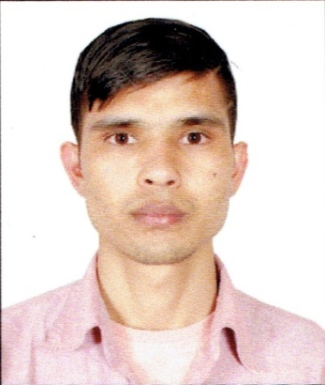
C/o-Cell No: 0503718643

Email: himal.376877@2freemail.com

Union, Dubai, UNITED ARAB EMIRATES

Career Objective
To provide consistent quality of food and beverage in all outlets in accordance with International standards with a purpose of exceeding guest expectations.Organizational profitability and ensuring an atmosphere of high team moral.
Academic Background
S.N | Level | Institute | Passed Yr. | Division
1 | SLC | Kali Gandaki Public Secondary School, Rupendehi | 2009 | 1St Division
2 | Certificate Level | Siddhartha Gautam Buddha college | 2011 | 2nd Division

Work experiences:
Food Land Restaurant & Party Palace
Position = commis I
2nd April 2011 to 6th 0ctober 2012

Hotel Vaishali
Position = CommisI
20th November 2012 to 2nd April 2014

Gorkha Nepali &Indian restaurant (Malaysia)
Position = commis I
13th may 2014 to 23rd October 2017

Duties & Responsibilities
- As a senior commie working in Indian cuisine.
- Making all Indian and Chinese dishes for day to day operation.
- Follow all guidelines of C.D.P. and SOU CHEF.
- Contribute to own idea for new menu and food quality
- Following all hygiene standards According to municipality.
- Wiling to knowledge and capacity to run single section Alone( Day to Day basis)

Training/Internship
- Completing industrial training in the Food production Department 6 month in Shangri-La training center.

IT-Skills
- Operating System : Windows
- Office Packages: Basic Computer Course Application (Word, MS Excel, PowerPoint), Email and internet.

Passport Details
Date of Issue: 17 Feb 2024 to16 Feb 2024
Visa Status: Visit Visa

Personal Information:

Date of birth: 18 Feb 1995
Nationality: Nepali
Marital Status: Single
Gender: Male
Language Known: English, Nepali, Hindi.

