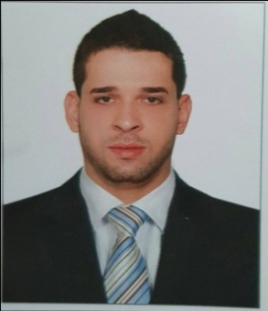
Ghazi
C/o- +971504753686
Ghazi.376880@2freemail.com

Born and raised in Dubai with 10 years of successful career in U.A.E with various reputed organizations. During my career journey I have established good working relations with Government officials that make my experience stronger.

Work Experience:

Samsons Group:
Jan 2012- Present

- DU Telecommunications
- Etisalat
- Pinne Apple Technologies
- Samsons Communications
- IL Caffe De Roma and Restaurant

Duties and Responsibilities

- Handled 12 license managing 300 employees solely
- Represent on behalf of the company and process all formalities with DNRD, MOH, MOL, DED, Courts, Police and other government bodies.
- Manage all government submission including but not limited to visit visa and employments visas, labor permits, car registrations, Trade License, Economic License
- Administer the portal system usage (e.g. Immigration/Labour /DED/etc.)
- Typing of Emirates ID and Medical test
- Process / Update / Renew of medical test of employees (restaurant) and license from health authorities MOH
- Timely renewal of visas, Trade licenses and immigration cards
- Assist employees with their dependents new visa, renewal and cancellation
- Proactively submit the cancellation and process exit pass for the employees as needed
- Application of visa quota
- Keep updated employee list every month
- Dealing with Notary Public with creation, rectification of Memorandum of Agreement
- Managing from A to Z business set up for new license
- Identify significant public policy issues that can be leveraged to support the work, and create and implement plans to exploit them
- Submit all receipts to finance for petty cash replenish
- Support GM, Hr and Admin department

Al Shamsi Group of Companies
March 2009- Dec 2011

Muhannad Documents Clearance and Business Set up
June 2006 – Jan 2009

Personal Details:

Age: 31
Nationality: Syrian
Place of Birth: Dubai – U.A.E
Education: High school
Driving License: Holding D/L Dubai
Visa Status: Residence Visa On Release
Language: Arabic, English, Urdu

Certifications and Awards:

Certificate of Appreciation from Dubai Police, U.A.E
Certificate from Computer Center (Sheikh Mohamed bin Rashid)

