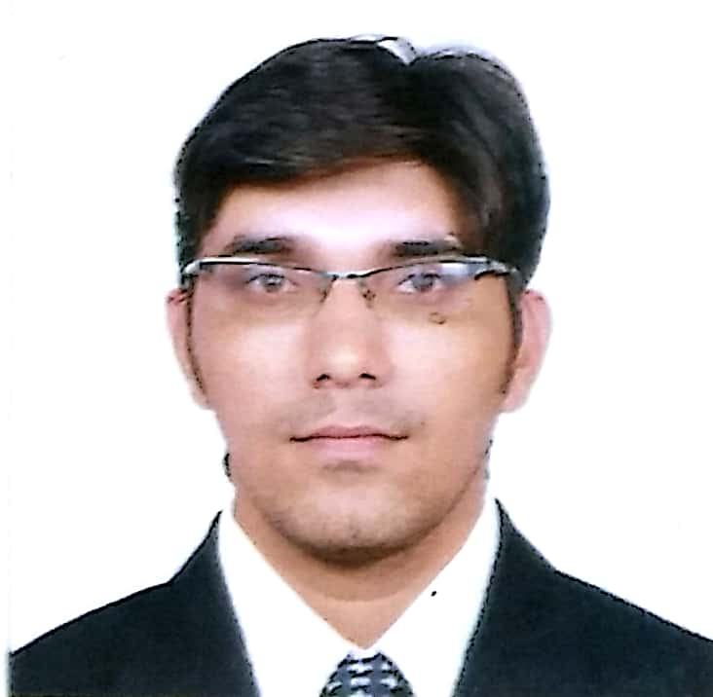  Vikram  Email  Vikram.376894@2freemail.com  Cellular  C/o 971505891826  Date of Birth  07Jan 1982  Gender  Male  Nationality  Indian  Marital Status  Married  Linguistic Proficiency  English, Hindi, Marathi, Konkani & Haryanavi | Objective  By excelling in Marketing, Sales, Distribution and Operation’s field, I envision myself to shine in the corporate limelight. Want to integrate learning with work, add value to the organization and self-growth by holding high responsibilities.  Experiences  - Currently working as BRANCH MANAGER for Big Joe and Company who are CnFA and Distributor for KELLOGGS INDIA, NESTLE INDIA and VODAFONE CELLULAR for Goa Region.(From 2015 to till date)  - Worked as Marketing and Sales Manager for “PERNOD-RICARD INDIA PVT LTD” for Goa and Maharashtra Region.(From 2008 to 2015)  - Worked as Territory Marketing Executive for United Breweries Ltd at Goa Region (From 2005 to 2008)  - Worked as Sales Officer In HDFC Bank, At Goa. (From JULY’2003 to March 2005)  Present Job Description  - Handling Sales Operations, Distribution and Logistics for Big Joe and company  - Handling Exclusive tie ups, 5 star Hotels, A CLASS Restaurants, and Institutions  - Handling 9 Distributors of the Goa and supervising a team of 22 Sales Executives, with Expansion & Development of Retail Market with Primary & Secondary Sales growth Accomplishment with required Resources.  - Handling promotions, visibility & marketing for Nestle and Vodafone.  Previous Job Description  PERNOD RICARD INDIA PVT LTD  - Was primarily responsible for the planning of Marketing and Sales activities for the Goa Market for the Brands like Chivas Regal, Absolut Vodka, Jameson, Jacobs Creek, Hundred Pipers, Blenders Pride, Royal Stag and Imperial Blue.  - Was responsible for handling a team of 15 sales men,3 supervisors for Sales and 12 Merchandisers,2 Marketing supervisors and 8 promoters for Marketing Activities  - Was handling Distributor with turnover of 180 Crore (Approx 28 Million USD) per annum  Areas of Interest  - Marketing, Sales, Customer & Distribution Management.

Education

Degree | College / University | Specialization | Year of Passing
B Sc | SPCC MARGAO,GOA UNIVERSITY | CHEMISTRY | 2003
HSSC | CBSE |  | 1999

Additional Qualification
- Done Six Month Professional Course in Internet Programming and e-Commerce from NIIT I

Extracurricular Activities

- Active Participation in Events Organized During the school & College.

- Reached Up to State Level Competition In Athletics. (2002-2003).

- Regular Blood Donor, since 1999

Computer Literate

- Languages Known C, C++.

- Operating System Known Windows.

- Packages Known MS Office.

Hobbies

- Reading about Current Affairs, Listening to Music, Cycling and Bike riding.

Date: 2/12/2017

Place: Goa Vikram

