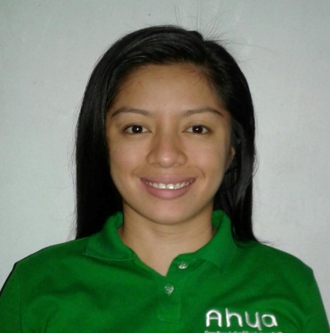
Kim

Ajman U.A.E
Cell: C/o 971501685421
Email: kim.376921@2freemail.com

I am aspired for securing an idea position that will utilize all my relevant and knowledge.

WORK_EXPERIENCE_________________________________________________________

AHYA COCO ORGANIC FOOD MANUFACTORING, PHILLIPPINES (June 2016 to June 2017)

Inline QA\ VCO In-charged
Working in the position of Inline analyst and handling all the duties and responsibility of this position efficiently, the duties are bellows;
- Verify raw materials against quality standards and adherence to specification.
- Prepare samples and solution for analysis.
- Perform quality control analysis (free fatty-acid, acid value, residual oil content, moisture content testing, iodine value, saponification and peroxide value determination).
- Perform physical tests on samples.
- Maintains the stock of lab supplies and equipment by keeping inventory records, organizing the stock, requisitioning supplies and logging information such as test performed, requested samples and damaged equipment.
- Perform assays and operate analytical equipment according to standard operating procedures and note any deviation for the procedure.
- Accurately record data and generate the report as needed.
- Supports product stability programs and process qualification.
- Supervise production team.
- Ensure all fund safety and quality requirement of the company.
- Other duties as assigned by management.

CELEBES OIL MILL INCOPORATED, PHILLIPPINES (April 2012 to May 2016)

Quality laboratory Analyst
Working in the position of laboratory analyst and handling all the duties and responsibility of this position efficiently, the duties are bellows;

- Perform quality control analysis (free fatty-acid, acid value, residual oil content, moisture content testing, iodine value, saponification and peroxide value determination).
- Prepare samples and solution for analysis.
- Perform physical tests on samples.
- Maintains the stock of supplies and equipment by keeping inventory records, organizing the stock, requisitioning supplies and logging information such as test performed, requested samples and damaged equipment.
- Perform assays and operate analytical equipment according to standard operating procedures and note any deviation for the procedure.
- Accurately record data and generate the report as needed.
- Supports product stability programs and process qualification.
- Ensure all fund safety and quality requirement of the company.
- Other duties as assigned by management.

L.C.TING INCORPORATED, PHILLIPPINES (February 2012 to March 2012)
- Assist document preparation for bidding project such as encoding, editing, and photocopying.
- Answering phone calls.
- And other duties as assigned by management.

EDUCATION_________________________________________________________________
Bachelor of Science in Biology major in General
Caraga State University
Philippines
2012

PERSONAL BACKGROUND___________________________________________________
Sex: Female
Height: 5’2”
Weight: 54 kg
Birthdate: January 30, 1989
Civil Status: Married
Nationality: Filipino
Visa Status: Residence Visa

