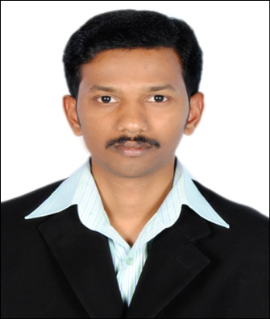
CURRICULUM VITAE

Abu Dhabi,
United Arab Emirates.
Contact No. : C/o 971505891826
Email : selvaganpathy.376994@2freemail.com

Position applied: Site Manager

OBJECTIVE:

To pursue a challenging position in a professionally managed organization with potential opportunity to contribute to its growth and enhance my skills, interested to work in Site Manager.

EDUCATIONAL PROFILE:
Course | Institution / University | Month & Year of Passing | Percentage
Hotel Management Catering Tech., | Global Inst. Of Hotel Management | April, 2008 | 88%
Bar Tending & Carving | IJTC Inst. Of Bartending, | Sep,2008 | 75%
SSLC | Govt. Boys High School | July, 2006 | 54%

IT’S EXPOSURE:

- Well-Conversant and proficient in MS-Office such as MS-Word, MS-Excel & MS-PowerPoint.
- Well known Operating Systems like Windows-XP & Windows-7.
- Well known about the ERP system (Enterprise Resources Planning). All over the transactions entered through ERP in our concern. I.e. Costing, Operation Module and HR module.
PROFESSIONAL STRENGTH:

- Managing the food and beverage provision for functions and events.
- Planning menus in consultation with chefs.
- Organizing, leading and motivating the catering team.
- Planning staff shifts and rotes.
- Ensuring health and safety regulations are strictly observed.
- Budgeting and establishing financial targets and forecasts.
- Monitoring the quality of the product and service provided.
- Keeping financial and administrative records.
- Maintaining stock levels and ordering new supplies as required.
- interacting with customers if involved with front of house work.
- Liaising with suppliers and clients.
- Negotiating contracts with customers, assessing their requirements and ensuring they are satisfied with the service delivered (in contract catering).
- Maximizing sales and meeting profit and financial expectations.
- Overseeing the management of facilities, e.g. checking event bookings and allocation of resources/staff.
- Planning new promotions and initiatives, and contributing to business development;
- Dealing with staffing and client issues.
- Keeping abreast of trends and developments in the industry, such as menus or trends in consumer tastes.

Work Experienced:

Company: National Catering Company – Abu Dhabi, UAE.

Position: Site Manager.

Project: Magenta Gulf Real Estate Management LLC,
Al Dabb`iya Surface Facilities Project III
(Dec, 2014 up to present)

Company: National Catering Company – Abu Dhabi, UAE.

Position: Unit Manager.

Project: Magenta Gulf Real Estate Management LLC,
Al Mafraq, Workers City #02, Abu Dhabi – UAE.
(Sep, 2011 up to Dec, 2014)

Company: Hotel GLM Meridian, – Chennai, India.

Position: F&B Dept. (Banquet).
(December, 2008 to July, 2010)

Company: A-Diet Express Hospitality Service Ltd, – Chennai, India.

Position: Food & Beverage Department (Training)
(October, 2007 to January, 2008)

Company: Hotel SRM (Royal Southern Hotels), – Chennai, India.

Position: Food & Beverage Department (Training)
(November, 2006 to February, 2007)

PERSONAL DETAILS:

Name : Selvaganpathy

Date of Birth : July 16th 1991,

Gender : Male,

Nationality : Indian,

Marital Status : Single

Vis Status : Employment Visa

Languages Known : Tamil, English, Malayalam & Hindi

Expected Salary : Negotiable

PERSONAL ABILITIES:

- Able to work as team player and Co-Ordinate activities with team members.
- Able to take up responsibilities and fulfilling them.
- Able to manage a team.

DECLARATION:

I hereby certify that the above information is true and correct according to the best of my knowledge and belief.

Place : Abu Dhabi, SELVAGANPATHY
Date : Applicant

