khalid
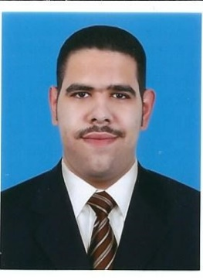
C/o 971501685421| Khalid.377026@2freemail.com |passed MOH exam

Objective
- Fine tone my skills and techniques to provide patients with aesthetic effective and painless treatment.
- Achieve master degree and increase experience

Skills & Abilities
- Endo treatment up to 2nd molar
- Provide aesthetic treatment
- Provide minimum surgical treatment
- Ability to lead co-workers
- Profound knowledge in office

Education
2011-2016 | Doctor of dental surgery (DDS), UAE, Ajman, Ajman university

Experience
2015 summer | Training, Solident dental lab  - Train on using cad/cam  - Observe the production of crowns, veneer and bridges  - Observe the production of full and partial dentures  - Observe the production of orthodontic appliances
2016-2017 | Internship, Ajman university  - Provide treatment in all aspect of clinical dentistry  - Observe number of orthodontic cases  - Treat patient from all range of age and ethnicity  - Provide emergency treatment for patients
2017-up to date | Residence, Ajman University

