PERMANENT ADDRESS :

SHIHA
Email: shihas.377031@2freemail.com
C/o 971501685421

Date of birth : 22.02.1991
Sex : Male
Marital Status : Single
Nationality : Indian

PASSPORT DETAILS

Date of Issue : 17.05.2012
Date of Expiry : 16.05.2022
Place of Issue : Trivandrum
Visa status : Employment visa valid till 2.5.2018

CAREER OBJECTIVE
Through constant learning, widen the horizon of my knowledge and achieve the best of abilities to develop my own acumen and sharpen my skills and utilize the same to the advantage of the organization and its surroundings. I am seeking role in a dynamic organization to contribute accrued expertise in charting a mutual growth path.

OVERVIEW & PROFFESIONAL EXPERIENCES

- Well organized, selfmotivated and hardworking medical/Insurance Coder.

- Worked as a medical coder, with Navigant India private limited (previously Revenue med India private limited Trivandrum India), from 31st March 2014 to 7th March 2016.
- Working as a medical coder, in Emirates international hospital Alain, Abudhabi from 9th April to till now

EDUCATIONAL QUALIFICATIONS

- COC (01361404) Certified from (AAPC) on 22/3/2015.

- ICD-10 Profficient as of 10/07/2015.

- Degree in BSC Nursing.
Board: Kerala University
REG NUMBER 10430
Institution: Sree gokulam nursing college

- Plus Two
Board: Board of Higher Secondary Kerala
Institution: Govt. Higher secondary school
Kilimanoor , Trivandrum, Kerala.

- SSLC
Board: Board of public Examination, Kerala
Institution: Ktctemrhss,kaduvayil
, Trivandrum, Kerala.

SHIHAS SHIHABUDEEN
CERTIFIED MEDICAL CODER (COC01361404) 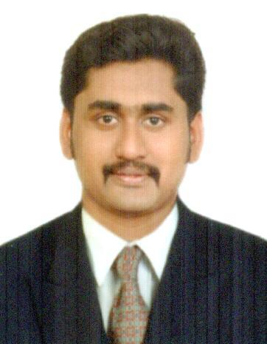

SOFTWARE SKILLS

3M, EPIC,
MS- WORD, MS-EXCEL and Internet Operation.
NATURE AND RESPONSIBILITY OF WORK

- Medical coding (E/M, ICD 9, CPT)
- Outpatient and ER files coding.
- Documenting patient history and record making
- Assigning proper diagnosis and procedure codes

INPATIENT CODING KNOWLEDGE

- Expertise in medical record review to abstract information required to support accurate inpatient coding.

- Expertise in assigning accurate ICD-10 medical codes for diagnoses and procedures performed in the inpatient setting.

- Solid understanding of anatomy, physiology, and medical terminology required to correctly code facility services and diagnoses.

- Understanding of outpatient reimbursement methodologies (OPPS)

SPECIALIZED AND EXPERIENCED AREAS

- Broad medical experience also includes billing, reimbursement, HIPAA rules, insurance verification, scheduling, and report creation

- Outpatient coding, Emergency, Evaluation and management, ancillary and radiology coding.

- Perform audit coding of disease and injury diagnoses, acuity of care, and procedures.

- Knowledge of medical terminology, anatomy, physiology and pharmacology.

- Assure the assignment of complete, accurate, timely and consistent codes by the medical coding unit

- Highly experienced in performing coder duties pertinent to the current International Classification of Diseases (ICD)-9, (ICD)-10, clinical Modification; American Medical Association Physicians’ current Procedural Terminology (CPT)-4; Health Care Common Procedure Coding System (HCPCS); Physicians ‘Desk Reference.

- Review and abstract relevant clinical data/medical records to select and sequence the appropriate ICD-9-CM, ICD-10 diagnosis.

- Extensive use of 3M Encoder pro.and CONCEPT

- Tutors new coders for compliance with ICD-9, classification systems and coding, regulatory guidelines.

- Strong proficiency of physician coding in and outpatient for the medical centre.

- Responsible for handling different types of medical claims
PROFFESSIONAL LICENSES

CERTIFIED OUTPATIENT CODER(AAPC)

MEDBERSHIP ID: COC (01361404)

ICD-10 Profficient

WORK PROFILE

Coding the patient documents by following the proper guidelines using the software’s like 3M, EPIC.

Assigning codes with highest specificity.

Maintaining quality without compromising the quantity of work.

LANGUAGES KNOWN

English, Hindi, Tamil & Malayalam

STRENGHTS

✓ Optimistic and Smart Worker

✓ Adaptability to change

✓ Strong analytical and problem solving skills

✓ Versatile & performance driven personality

✓ Good communication skill

✓ Quick learner and Go getter

✓ People Management & Leadership Skills

I hereby declare that the above information provided by me is true to the best of my knowledge and belief. I assure you my hard work, dedication, sincerity and commitment to deliver the valuable and successful medical services to your organization.

SHIHA

PLACE: ALAIN

