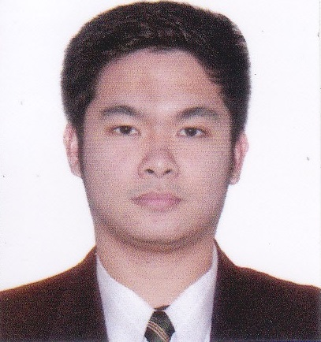
Name: Jake
Telephone: C/o 971501685421
E-mail: jake.377039@2freemail.com

LICENSES:
- International Medical Laboratory Scientist, MLS(ASCP^{i})^{CM} Passer, November 2017
- Medical Technology Licensure Exam Board Passer, August 2017

RELEVANT EXPERIENCE
Medical Technology Internship, November 30, 2015 - June 1, 2016
St. Lukes Medical Center - Quezon City
- Trained under Pathology Department - Ancillary Services
- Exposed to Different Sections such as Histopathology, Serology, Clinical Microscopy, Hematology, , Cellular Immunology, Blood Bank, Microbiology, Clinical Chemistry and Phlebotomy
- Perform Autocyte procedure and staining under Histopathology section for Pap smear supervised by section staff on duty
- Exposed to different automated machines such as Sysmex Cs 2100i, Sysmex XN 3000, Dimension RXL 1 Siemens, Immulite XPI 2000,Kwiklyte, Immage, Vidas, Sysmex UX 2000, Architect i1000 ISR, Cobas Roche, Osmometer Model 3320, Variant II BIO RAD,, Siemens ClinitekAdvantus, Siemens, Sysmex CA 1500, DCA Vantage Analyzer, Sakura Tissue Tek and special test such as PHADEBACT for Bacterial meningitis,, Cyptococcal Antigen, Latex Agglutination System, and Typhidol Salmonella.
- Performed quality control of machines supervised by section staff on duty
Armed Forces of the Philippines Medical Center, December 3, 2016 – June 2, 2017
- Trained under pathology Department
- Exposed to Different Sections such as Blood Bank, Clinical Chemistry. Clinical microscopy, Bacteriology, Histopathology, Serology, Hematology, phlebotomy, and Information Section where you receive specimens and deliver it to different sections in the lab, accommodate patients, receive phone calls, and release results.
- Perform extraction on patients without the supervision of staff or nurse
- Accommodate and ran the specimens for the candidate of cadets of Philippine Military Academy for the year 2017
- Perform manual procedures on different sections in the laboratory.
- Part of the team sent to bloodletting activities.
EXTRACURRICULAR ACTIVITIES
- 2013-2016 participant Medtech day (men’s) Basketball team
- 2015-2016 Participant Medtech day (men’s) Volleyball team
HONORS, AWARDS & CERTIFICATION
- Dean’s List, 2013-2014
SEMINARS, TRAININGS, AND CONGRESSES ATTENDED
- 1st year TUA-CMT Recollection - Values Seminar, July 2013
- TUA-CMT Philippine Red Cross - Quezon City Chapter: Basic Life Support Seminar, March 2015
- TUA-CMT Values Seminar For 3rd yrs. Students, July 2015
- 3rd year TUA-CMT Values Seminar , March 2016
- Trinity University of Asia - College of Medical Technology 3rd CMT Annual Symposuim: “Neglected Tropical Diseases: Role of Medical technologist, Challenges and Opportunities 2017
- St. Lukes’s Medical Center – Institute of Pathology Postgraduate Course: “Clinical Utilities of New Laboratory Parameters” 2016

PERSONAL DATA
Nationality: Filipino Religion: Roman Catholic
Sex: Male Date of Birth: May 23, 1997
Marital Status: Single Place of Birth: Quezon City, Philippines
EDUCATION
- Secondary School
Our Lady of the Sacred Heart School (Plaridel St., Quezon City, Philippines), March 2013
7th honorable mention
- Tertiary
Trinity University of Asia (Quezon City), May 2017
Bachelor of Science in Medical Technology

I hereby certify that all information stated above are true and correct with best of my knowledge and belief.

JAKE
Applicant

