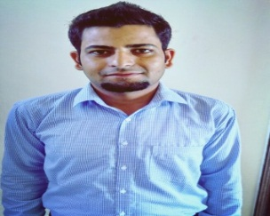
Asam
Contact: C/o 971505891826
E-mail id: asam.377041@2freemail.com

Summary:
Solution Focused, Result oriented Retail Sales Manager Professional offering more than 4 of experience in sales, operations &Business Development .working in challenging environments, where every situation required immediate attention. I quickly learn to handle various situations professionally and efficiently with available resources.

Professional Experience:

Future retail limited Mar 2017 - Present
Team leader
Responsibilities: 
- Sales & operation of store.
- Control the Shrink & Dump of the Store.
- Responsible for the Store Audits.
- Team Handling.
- Control the Store Budget.
- Work on Store Profit & Loss.

Indulge Beverages (Pvt.) Ltd (Bonhomia) Sep 2015-Dec 2016
Retail sales Executive
Responsibilities:
- Key accounts handling.
- Generate the revenue by Identifying, Analyzing and Acquiring Key Accounts/ Retail & Institutional Accounts across City for Bonhomia Coffee Brewer.
- Handle sales, Customer support service, Stocks of the company, & Promotions across the city.
- Team Handling.
- Store sales and promoters training.
- Responsible for the demonstration of coffee brewer to different potential place.
- Engaged in New Business Initiatives, Generate New Product Development Ideas, Introducing New range of products to client.
Jai beverages pvt ltd jammu Mar 2011-Apr 2013
Customer executive modern trade
Responsibilities:
- Accountable for Distribution and sales tame Handling,meeting sales target,planning &execution in modern trade
- Driving Volume and growth in given territory i.e jammu.
- Merchandising and promotion.
- Managing & developing of Team
- Key Accounts Handling.
- New Customer Development

Education:
- M.B.A from University School of Business Chandigarh University 2015
- B.B.A from Dept. of Commerce & Management Kashmir University 2013

Co-Curricular Activities:
- Member of Green Club.
- Member of Cricket Team.

Personal Detail:
Date of Birth: 01-01-1990

