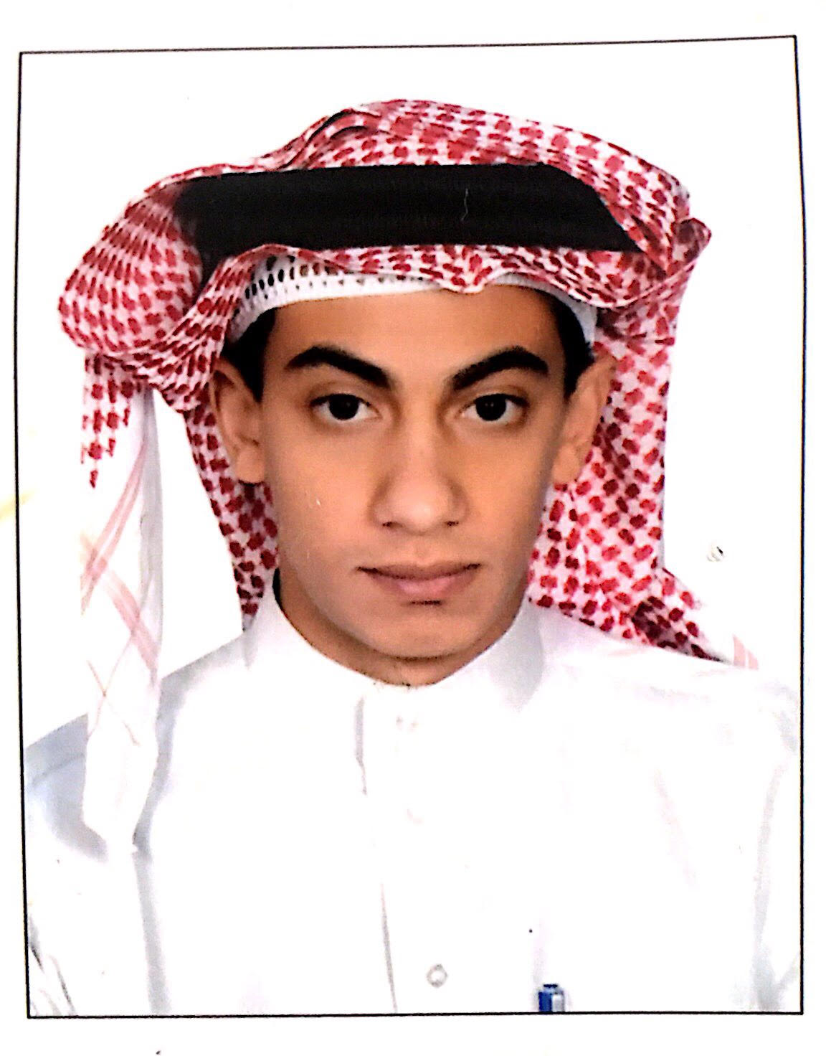
Abduljawad

Personal Information

Born: Riyadh – Saudi Arabia - May 20, 1992
Address: KSA – Medina
Mobile Phone: C/o 971501685421
Email: abduljawad.377121@2freemail.com
Marital Status: Single
Nationality: Palestinian (Son of Saudi Mother)

 | Education
 | College:  GPA:  Specialization:  Qualifications:  Graduation Year: |  | Yanbu Industrial College  2.79 out of 4.00 (GOOD)  Mechanical Engineering Technology  Bachelor Degree of Mechanical Engineering Technology  Associate Degree of Mechanical Maintenance Technology  Bachelor degree – January, 2018  Associate degree – September, 2014
 | Work Experience
 | 2017  (July-Sept)  2 Months  2014 – 2016  (Dec 5 – Jan 6)  1 Year + 1 Month  2014  (May - Sept)  4 Months  2014  (May - July)  2 Months |  | Saudi Arabian Airlines, Medina Station  As a Coop Trainee  Al-Jazirah Vehicles Agencies Co.Ltd, Medina Branch  As a Mechanical Maintenance Technician  Ministry of Water & Electricity, Medina Station  As a Coop Trainee  Mandarin Supermarket, Medina Branch  As an Accountant
 |  | Languages

Arabic: Native language

English: Excellent level in speaking, listening, reading, and writing

Skills & Performance

Technical Skills:

- Make analysis for different vehicles and Mechancial Parts and deciding what it shoud be done.
- Applying preventive and corrective maintenace for mechanical parts (brake pads, shock absorber, pulleys, belts, etc.) as well as lubricate the different mechanical parts.
- TroubleShooting, inspecting, and investigating about any leakages or any defictive parts as well as predicting any futured problems.
- Submitting a full report about the whole job.

Computer Skills:

- Very Good level in using Microsoft office softwares ( Word, Excell, and Power Point).
- Using SolidWork & AutoCAD softwares to design desired 3D & 2D Engineering models
- Using TEST software to calculte the different properties of any power plant cycles
- (Pressure, Temparature, Entropy, Mass flowrate, Thermal efficiency).

Communication and other Skills:

- Dealing with different types of customers and clients and try as best as possible to meet their requierments and desires.
- Creating a suitable teamwork to accomplish a particular or multiple tasks efficiently as well as effectively.
- Selecting the right workers for the right job to achiave the right goal.
- Listening and following the instructions and commands.
- Leading, inspiring, and encouraging other workers in order to finish multiple tasks in less time with high results
- Work beneath each sky and above each earth, no matter how hard the work is, at the end it should be Finished.

