Dr. MEGAN
GENERAL DENTIST

FF
A confident communicator who can relate well to dental patients. Having a proven ability to ensure that dental practices in a surgery are continuously updated to provide first rate care to patients and their families. A confident healthcare professional with a long track record of successfully diagnosing and treating patients' dental conditions. Able to work as part of the dental team, and has a flexible approach to work. Looking for a General Dentist opportunity to work with a forward thinking in a highly regarded dental organisation.

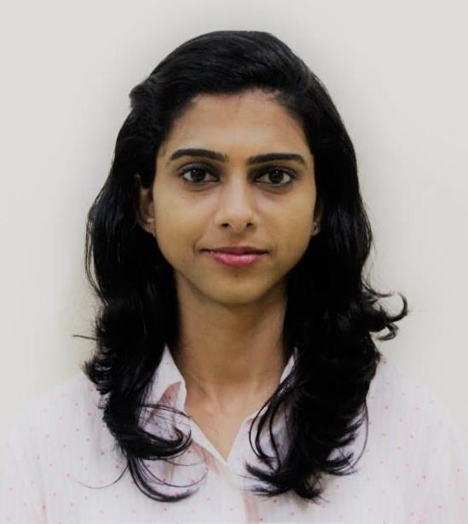

📱: C/o 971501685421
: megan.377132@2freemail.com

AREAS OF EXPERTISE

- Laser Dentistry

- Paediatric dentistry

- Oral surgery

- Crown

- Removable Orthodontic treatment

- Bleaching and micro abrasion & composite restorations

- Cosmetic dentistry/ smile re-designing

- Root canal treatments

- Non extraction fixed orthodontic appliance

- Marketing dental services to potential clients

PROFESSIONAL EXPERIENCE:
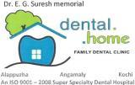
Dental Home Super speciality Dental Clinic
GENERAL DENTIST (April 2015 – April 2017)

Worked in a busy ISO 9001:2008 certified super speciality dental clinic with 10+ speciality dentists, dental health educators, Residents, hygienists, dental nurses, providing a full range of dental treatment to patients to help them maintain oral health. Spends a significant amount of time standing and using specialist equipment. Works as part of a dental team, comprising of dental nurses, dental hygienists and dental health educators. My fortes are Paediatric Dentistry, Laser Dentistry, non-extraction fixed orthodontic therapy, Complete and Removable dentures, aesthetic restorations, Crown preparations ,extractions and last, but not the least, Trauma care.
DUTIES
- Presented full range of dental care services to patients.
- Dealing with routine appointments and check-ups, taking
impressions etc.
- Dealing with emergency cases like relieving a patient’s
pain.
- Supervised the daily activities of dental assistant, dental
hygienist and dental residents.
- Monitored quality of patient care through a peer review
system, medical record quality, and laboratory and x-ray
usage.
- Monitored and adhered to all infection control and safety
procedures.
- Performed general dentistry services, including the
diagnosis and treatment of diseases, injuries and
malformations of teeth, gums and related oral structures.
- Assist senior doctors for several cases of dental treatment
PROFESSIONAL LICENSURES

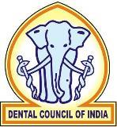

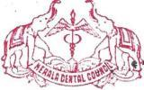
Kerala Dental Council Registered: A-13788

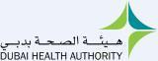
Eligibility-ref no- DHA/LS/682017/738114

PERSONAL SKILLS

Able to concentrate for long periods.

Attention to detail.

Communication skills.

Relieving patient’s anxiety.

Motivated.
Disciplined and efficient working manner.

Enthusiastic and determined.
Professional and energetic demeanour.

under general anaesthesia for paediatric patients.
- Extensive knowledge and experience to diagnose wider
range of diseases pertaining to oral and perioral regions.
- Skilled at formulating plan of treatment for patient's teeth
and oral tissue.
- Ability to write prescriptions for antibiotics and other
medications.
- Ability to advise and instruct patients regarding preventive
dental care.
- Extensive experience in treating a wide range of patients
including very young to very old.
- Wider experience in diagnosing and advising early
interceptive and other preventive modalities like pit and
fissure sealants, fluoride application, twin block appliance,
head gears, hyrax etc.

Indira Gandhi Institute of Dental Sciences, Kothamangalam, Kerala, India
HOUSE SURGEONCY (March 2014 - March 2015)

Experience in casualty handling trauma cases including fractures, suturing head and neck lacerations etc...
Internship included Root Canal treatments, Crown cuttings, Anterior Composite Restorations, Trauma care, Extractions, Impactions, experience in handling patients with OSMF, Carcinoma, Mucocoele, Leukoplakia, Candidiasis etc., IOPAs, Pit and Fissure sealants, Fluoride application, twin block appliance, head gears, hyrax etc., permanent retainers, Hawley’s retainers and other orthodontic appliances, supra and sub gingival scaling etc...
Computer Skills

KEY SKILLS AND COMPETENCIES
- Well-presented and articulate.
- Experience of advising patients on diet, brushing & other
aspects of dental care.
- Keeping up to date with the latest developments in
dentistry.
- Excellent listening, communication and interpersonal skills.
- Able to write prescriptions for antibiotics and other dental
Medication.
- Behaviour management and modification of child patients.

ACADEMIC QUALIFICATIONS
Bachelor’s Degree in Dental Surgery from:
Indira Gandhi Institute of Dental Sciences, Kothamangalam, Kerala, India. (2008-2015)

CERTIFICATIONS / CONFERENCES ATTENDED
- Certificate of participation – Lecture on Endodontic practice
– Level Next 1.
- Certificate of participation for CDE on ‘ Annual conference
of Kerala society of Pedodontics & Preventive Dentistry.
- Certificate of participation on ‘Emergency care and Basic
Life Support’.
- Attended ‘Nobel Biocare meet- Implant & Esthetic Dentistry’
- Certificate of participation for a project – ‘FREE
DENTURES FOR SENIOR CITIZENS’ – by Rotary Club of
Perumbavoor Central.
- Paper presentation at the clinical society meeting on “Pit &
Fissure Sealants”.
- Represented college at various competitions at the district
and state levels.

PERSONAL DETAILS
Name: Megan
Date of Birth: 10-10-1989
Gender: Female
Marital Status: Married
Visa status: U.A.E. Residence Visa

