SIVAGURUNATHAN
Industrial / Lean Engineer with International Experience
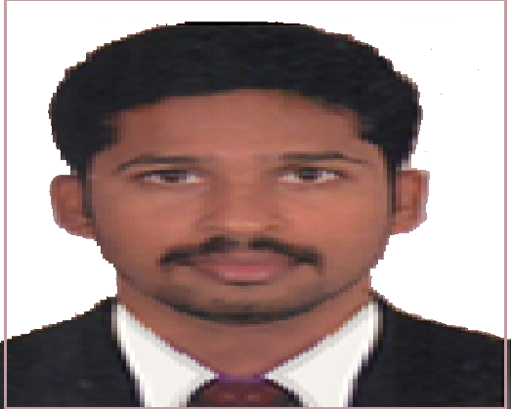
Nationality: India, Current location: Dubai
sivagurunathan.377133@2freemail.com
C/o 971501685421

OBJECTIVE Seeking a position in demanding and learning environment in international level wherein can use my skills as an experienced professional to drive a consistent approach towards Facility and lean engineering responsibilities for achieving the organization goals and objectives efficiently & effectively.
EDUCATION
Master degree
Industrial / Lean Engineering - (7.01 CGPA)
PSG College of Technology (AU) India-2012 Bachelor degree
Mechanical Engineering – (70%)
Bannari Amman Institute of Technology (AU) India-2009

PROFILE SUMMARY
A dedicated and result oriented qualified Facility and lean engineering professional with over (03) years of experience in manufacturing industry in mid-level management positions.
Challenged with increasing product quality, improving process flow, and reducing costs while manufacturer. Develop, evaluate, document, and advance manufacturing methods and processes through Lean techniques and Kaizen Events.
RESPONSBILITIES
- Supervision in production line & troubleshooting, responsible for productivity.
- Implemented concept of continuous improvement to eliminate the waste in manufacturing & Administrative process.
- Designed floor layout changes to facilitate the free flow of product parts from Production cells to assembly area.
- Utilized Lean exercises / tools to identify the areas of improvement that result in cutting unnecessary costs.
- Implemented Just-in-Time (JIT) techniques to optimize the throughput time.
- Responsible for manpower distributions.
- Responsible for the Inventory of finish goods.
Teaching experience: 2
- 2 Years of experience in teaching at engineering university Africa

TIMELINE
Madras Radiators India 2012
Sun Max Engineering works India 2012-14
Dire Dawa University Ethiopia (Africa) 2015-17

SOFTWARE SKILL
Igrafix, Timer Pro- (Identify Non Value Added Activity software)
Auto cad-(2D Modelling) , Microsoft office

CORE COMPETENCE
- Cause And Effect Analysis
- Continuous Improvement (Kaizen) Activity’s.
- Identified and corrected efficiency bottlenecks

PRESONAL DETAILS
LANGUAGES KNOWN: Tamil, English

PASSPORT
Date of Expiry: 25/05/2024
Previous country worked: Ethiopia (Africa), Visa No: VS2645823

