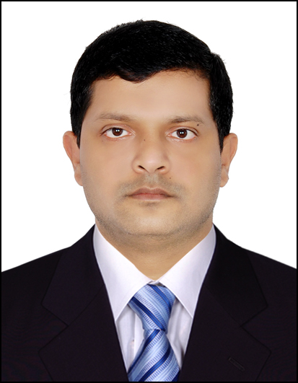
Aftab
Dubai, U. A. E.
Mob: C/o 971503718643
Email address: aftab.377149@2freemail.com

_____________________________________________________________________________

Career Objective:

Highly organized, having strong inter-personal communication skills. Acquired abilities to deal with guest at all levels in modern hospitality Industries self-confident, well motivation, Honesty, Healthy and flexible to work any shift/any kind of job if you required.

Achievements:

- Intermediate in Food Safety Management from Dubai.(U.A.E)
- Pre-opening Team Certificate,
- Employee of the Month Ibis Hotel, Dubai,
- Employée of the Year Ibis Hôtel, Dubaï,
- Basic Food Hygiene Certificates from Dubai-(U.A.E)
- HACCP Awareness Certificate from Dubai,(U.A.E)
- Chemical Handling Certificate from Dubai, (U.A.E)
- Fire Fighting Certificate From Dubai Civil Defense,(U.A.E)
- First Aid Certificate from Dubai (U.A.E).
- Fire Evacuation Certificate from Dubai,(U.A.E).
- Cost Control for Kitchen Certificate from Dubai (U.A.E)
- Supervisor Toolkit 1 Certificate from Dubai (U.A.E)
- Communication essentials.

PROFESSIONAL EXPERIENCE

Fassco International Catering Company (Latifa Hospital)

As a Stewarding In-Charge, Since 16th Aug 2017 till 25th Jan 2018

Previous employment

Ibis Hotel Al Rigga( Accor Group) 280 Rooms and 3 f&b outlets,24 Hours
Room Delivery.

As a Stewarding Supervisor, Since Jan 17th 2010 till Jan 30th 2017

Description of Duties
- Understanding of appropriate cleaning techniques, requirements and use of equipment
- Flexible in work timetable together with weekends, nights and holidays.
- Experience in maintaining hotel standards, policies and procedures, prioritizing and arranging work assignments.
- Can undergo a variety of physical movements throughout the work areas.

- Skilled in Hospitality and customer service role
- Maintain the cleanliness of the Kitchen as per HACCP Policy.
- Able to achieve assigned duties with attention to detail, pace, correctness, follow-through, good manners, cooperativeness and work separately
- Expert in chemical handling properly and safely

Shahi Hotel & Apartment 3 Star (All India branches)
260 Rooms Hotel Industries in Kolkata (India).
Stewarding Supervisor , since 27th APR2008 till 28thDEC 2009.

Description of Duties
.
- Cooking helping in hot kitchen
- Prepare daily requisition of stocks needed for the daily operation
- Handle inventory of stocks
- Maintain the cleanliness of the surroundings HACCP.
- Preparing quality of standard food preparation.
- Maintain the cleanliness of the Kitchen as per HACCP Policy.

Sun & Sand Hotel in Mumbai City Center

As a Stewarding since 21st FEB 2004 till MAR 20st 2008

Description of Duties
- Maintain the Cleanliness of Chinaware as HACCP Standard
- Prepare daily requisition of Stewarding cleaning Chemical
- Handle inventory of stocks
- Maintain the cleanliness of the surroundings HACCP.
- Preparing quality of standard food preparation.
- Maintain the cleanliness of the Kitchen as per HACCP Policy
EDUCATIONAL
QUALIFICATION - Intermediate.(10+2) From Kareem City College ( Jharkhand )

PERSONAL
DATA Birth Date : March 12th 1982.
Civil Status : Married
Religion : Muslim
Nationality : Indian
Height : 5”7

I hereby certified that all information above is true and correct to the best of my knowledge and belief.

__________________________
AFTAB

