Maryna

Wedding and family photographer

Maryna.377169@2freemail.com

Education

Specialist | 1998 - 2003
NATIONAL UNIVERSITY "ODESSA LAW ACADEMY"

Criminal law. Judicial and prosecutorial faculty

http://onua.edu.ua/

Work experience

Wedding and family photographer 2010 - Present

Provided photography services to clients for individual, wedding, and family portraits, sport reportage, events. Set up equipment at the venue and capture moments at class reunions, weddings, parties, etc. Retouched photos using Lightroom and Photoshop. Edited, toned and uploaded photographs to websites and servers. Built relationships and consulted with clients during pre and post production to meet their needs. Executed digital photography work flow: capturing, downloading, editing, printing, backup and cataloging. Trained an assistant. Created, posted and managed updates and responses for all online content for my brand's social media.

Director/Co-owner | 2016 - 2018
Travel Agency

Motivating a team of six travel agents to achieve and surpass pre-set goals and targets. Over seeing the bookings procedure and ensuring accurate processing. Managing and training staff in every area of business. Forging long term and positive relationships with new and existing customers. Providing insurance and ad on options to all customers. Researching competitors’ deals to ensure the agency remained competitive. Dealing with and resolving any complaints, issues or problems that arose. Created, posted and managed updates and responses for all online content for the brand's social media. Wrote long form editorial content for the site.

Grocery Shop owner | 2009 - 2010
Grocery Shop

Managed, supervised and provided leadership to up to 4 employees. Stocked shelves, racks, cases and bins with new merchandise; prepared food displays. Determined if inventory was sufficient for needs; ordered merchandise when necessary.Interacted with vendors; prepared purchase orders; tracked status of requisitions and orders. Ordered and received all shipments of inventory. Updated price changes from week to week for store sales and discounts. Managing and motivating team to increase sales and ensure efficiency. Received and unloaded ship merchandise. Answered customers' questions about merchandise and advised customers on merchandise selection. Provided excellent customer service

Judicial Assistant | 2009 - 2009
Primorskiy court of Odessa

Recorded outcomes. Attended hearings. Made records. Pre-case related work. Worked closely with the

Judge. Conducted legal research and prepared memoranda on pending cases. Participated in daily court activities processing real time data entry for both court record and sentencing orders

Assistant /office manager of State Notary | 2004 - 2009
The Fifth State Notary Office

Answered the phone, assisted client with their needs, Internet search, updated the files, followed ups with clients, setting appointments, keeped myself informed about new laws, filling out applications for various matters, faxed documents, made copies. Worked with special notary programs. Registration of inheritance, prepared contracts, applications, powers of attorney, photocopies and other notarial documents

Assistant /office of Private Notary | 2003 - 2004
Private Notary Viktoria Trofimets

Answered the phone, assisted client with their needs, Internet search, updated the files, followed ups with clients, setting appointments, keeped myself informed about new laws, filling out applications for various matters, faxed documents, made copies. Worked with special notary programs. Prepared contracts (preparation of contracts for obtaining a bank loan for the purchase of real estate or car), applications, powers of attorney, photocopies and other notarial documents

Personal Details:
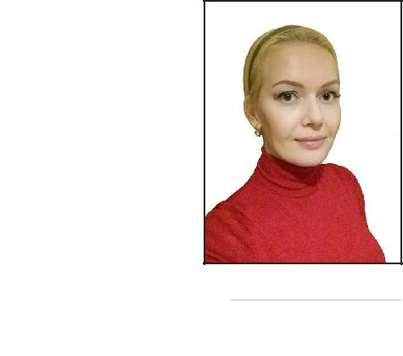

Date of birth: 07 January 1981 My height is 5'11' (180 cm)

Languages known:

English - Intermediate,

Turkish - Elementary,

Russian - Native,

Ukrainian - Native

Photoshop, Lightroom, CorelDraw, Wordpress

