Curriculum Vitae
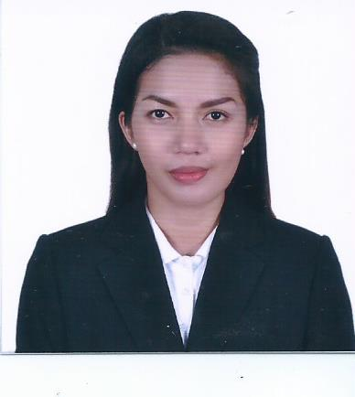
Name : Prexy
Address: Ajman, United Arab of Emirates
Tel: C/o 971505891826
E-mail: prexy.377242@2freemail.com
Career Objective:
Seeking a position to utilize my skills and abilities in a company that offers professional growth while being innovative flexible.
Personal Summary:
Bachelor Degree of Criminology, I’m a fresh college graduate with work experience in Customer Service/Receptionist.
A challenging role dealing with customers being motivated to maintain customer satisfaction and contribute to company success. Reliable and driven, with strong time management and prioritization abilities.
A polite, friendly and extremely capable receptionist, with a passion for delivering excellent administrative support. I hold excellent communication and listening skills that allow me to communicate successfully with all clients and guests, face-to-face and over the phone.
Outgoing and detail-oriented proficient at building and maintaining professional relationship. Though my degree is not related to my experience, I strive to achieve the best in all areas, and I am always eager to learn new skills and advance my career and I am keen to build upon my knowledge and continue to learn.

Work Experience:
Company Name: Cignal Cable Davao Company: Cable and Satellite Services Business
(May10, 2016-December 30, 2017)
Position: Customer Service/Receptionist
Responsibilities and Duties:
- Receiving visitors at the front desk by greeting, welcoming, directing and announcing them appropriately.
- Receiving and sorting daily mails and inquiries.
- Answering and screening and forwarding incoming calls.
- Direct visitors to the appropriate person and office.
- Identifying and assessing customers’ needs to achieve satisfaction.
- Provide basic and accurate information in-person and via phone/email.
- Handle customer complaints, provide appropriate solutions and alternatives within the time limits; follow up to ensure resolution. Keep records of customer interactions, process customer accounts and file documents.
- Order front office supplies and keep inventory of stock.
- Update calendars and schedule meetings.
- Perform other clerical receptionist duties such as filing, photocopying, transcribing and faxing.
- Follow communication procedures, guidelines and policies.
Skills:
- Professionalism
- Communication Skills
- Organization
- Computer Skills Proficient with MS Word, Microsoft Outlook and Basic Excel
- Email, Social Media
- Documentation
- Multitasking Capability
- Administrative Support
- Filing
- Technology Skills
- Front Desk Operations
Educational Background:
High school: Saint Michael School Of Padada
Year: 2009-2012
College: Polythicnic College of Digos City
Course: Bachelor Science in Criminology
Year: 2012-2016

Other Information:

Date of Birth: November 17, 1995 Visa Status: Visit Visa
References: Available upon request Nationality: Filipino

