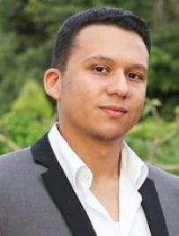
Foaad
Mobile: C/o 971501685421
Email: foaad.377267@2freemail.com

Foaad
Personal Information :
Nationality:
Egyptian
Gender:
male
D.O.B:
6-may-1992
Mobile:
C/o 971501685421

Experience :
1) working at EL-Ezaby call center & pharmacies from march
2017 till now .
2) Working in family and infant care in giza
3) Medicalrep training at pfizer company in 2014.
4 ) Training at Abo Ali pharmacy in 2013 .
5) working at Mahmoud AL_kashef pharmacy at 6th October
In 2015 .

Areas of Expertise/Skills :

Research Customer Service
Communication Sales
Presentation MS Office
Active Learner Time Management
Attention to Details Interpersonal Skills
work uder stress

Training Courses/Certificates :

● OTC advanced cource ( DR. Ahmed AL-gwaily ) .
● ICDL course .

Education :

● B.Pharm Degree from Helwan University, College of Pharmacy, (Egypt) awarded in June 2015
with a certificate of very good.

Language :

● English very good (both oral and written)
● Fluent in Arabic (both oral and written)

