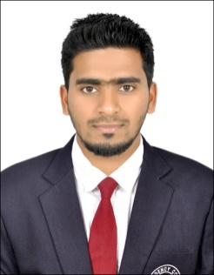

SHABEEB

Tel: C/o 971504973598 E-Mail: shabeeb.377268@2freemail.com

Address: - Dubai

OBJECTIVE/PROFILE

Ambitious to build a career in finance and marketing with an organization where teamwork is required and hardworking is appreciated and to be in a position which is best suited to my knowledge, skills and ability

EDUCATION PROFILE

- Master of Business Administration (Finance and Marketing)
Bangalore University, India

- Bachelors of Business Administration
Calicut University, Kerala, India

CAREER SNAPSHOTS
- Company profile
Experience: - May - October 2017- Just dial.com

Roles and Responsibilities (Certified Internet Consultant) Kerala
- Arrange and meet commercial establishments those are located within area allocated
- Send Key Parameter Monitor report to the managers on daily basis
- Submit the contracts to the office with proper and valid documentation
- Follow up and collection of payments from the clients
- Deposit the cheque in the bank
- Ensure that the contract cheque is claimed and the account of the client is activated within the mentioned time frame

- Company profile
Experience: - June 2014- July 2015:- KVR Auto Cars Pvt Ltd

Roles & Responsibilities [Accountant]
- Documents financial transaction by entering account information
- Prepares Petty cash Book
- Prepares the sales reports on monthly basis
- Reconcile the Bank accounts monthly basis
- Deposit the cheque and cash in to the bank account
- Assist in preparing annual budgets
- Undertake any other specific duties as required by the Finance manager.
- Summarizes current financial status by collecting validation and information acquired
- Secure financial information by completing data base backups

CERTIFICATIONS/INTERNSHIP

- Certification In SAP Financial Accounting At the Basic Level
- MS Office: MS Word, MS PowerPoint, MS Excel
- Tally
- Peachtree
- Mayob
- QuickBooks
- Completed Internship on Explaining the variant principle and fiscal year variant
- Completed Internship on Effectiveness of Distribution Strategies with Reference to ATC Footcare
- Completed Internship on Effectiveness of Advertisement of AM Honda, Angadippuam

PERSONAL DOSSIER

Date of Birth: 7th July 1993
Nationality: Indian
Marital Status: Single
Visa Status: visit visa valid till February 15
Language: English, Malayalam, Tamil

I hereby declare that the above furnished details are true and correct to the best of my knowledge and belief.

Thanks & Regards

SHABEEB

