RESUME
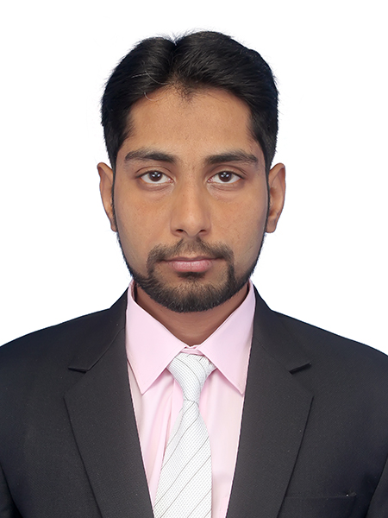
Hussain
Mobile: C/o 971501685421
E-mail: hussain.377273@2freemail.com
VISA Status: Visit Visa – (27 Jan 2018 – 22 April 2018)

Objective
Seeking a challenging position in a company that appreciates the good work and provides a suitable environment where I will be able to develop my knowledge and my work experiences, and I will be able to contribute to its growth and prosperity as a member of a team.

Education
Masters of Engineering
Mechatronics Engineering,
NED University of Engineering and Technology, Karachi, Pakistan
Cumulative GPA= 3.03 (2014-2016)
Bachelor of Engineering
Biomedical Engineering, with specialization in Medical-Engineering
NED University of Engineering and Technology, Karachi, Pakistan
Cumulative GPA= 3.0 (2009-2013)
Experience
Field Service Engineer
Meditec Instruments Company Jan 2014-Dec 2017
➢ Experience of handling Laboratory Instruments such as Electrolyte analyzer, Blood Gas Analyzer
(ABG), Hematology Analyzer(CBC), Semi-auto & Fully Auto Chemistry Analyzers with both Special & Routine Chemistry parameters, Immunoassay Analyzers etc.
➢ Work on MEDICA (USA) Electrolyte, Bloodgas & Auto-chemistry Analyzers as well as different Hematology Analyzers (3-part & 5-part) of MINDRAY (CHINA), Immunoassay Analyzer from WondFo (CHINA).
➢ Having efficient knowledge and working experience on hardware and software of these machines.
➢ Do repair of Power supply boards, analog Signal boards, Power driving boards and CPU Boards on component level.
➢ Repair of Electromechanical assemblies such as Pressure Pump, Vacuum Pump, Solenoid Valves, DC/Stepper motors etc.
➢ I am responsible to provide support service activity to all healthcare related organizations up to the expert level.
➢ Training of customers and service engineers.
➢ Dealing with technical queries from hospitals and laboratories and giving advice on new equipment.
➢ Maintain spare parts stock.

INTERNSHIPS
15 days Internship at National Medical Centre, Karachi.
5 months training at Ziauddin Hospital Clifton, Karachi.
Skills
- Experience of projects related to electronics and mechanics and related software like Proteus Professional, Circuit Wizard, AutoCAD 2D/3D, Pro-E (Also design wheel chair with all its detailed features).
- Command on MS Office (Word, Excel, Power Point), Minitab, LabVIEW, MATLAB.
- Design circuits using Micro-controller such as Arduino, PIC etc.
Projects
Centralized Drip monitoring & Controlling System(Final Year Project)
- Pulse Meter/counter
- Micro-controller based Robotic Car
- Goniometer
- Sensitometer
- 15V adjustable +/- Power Supply
Personal Attributes
Authority: Confidence to do whatever I think.
Communication Skill: Ability to articulate and can develop logical solution.
Responsibility: For making decision and facing consequences.
Challenges: Can work in any demanding environment.
Language Preference
- Urdu (Fluent)
- English (Conversational – Advanced)
- Arabic (Basic)

Hobbies
- Reading News Papers, story books & Science magazines
- Surfing on net
- Playing cricket

Personal Bio-data
Name: Hussain
D.O.B: 05th April, 1990
Religion: Islam
Nationality: Pakistani

