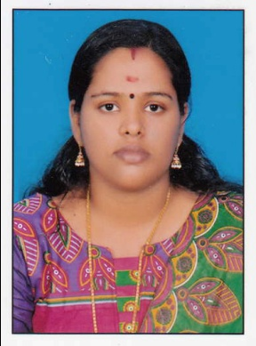
RESUME

SANDRA
Email: Sandra.377392@2freemail.com
Mobile: C/o 971501685421
MOH NO : RN 009500
Career Objective:

To Secure a Deserving Position in the field of Nursing in your Esteemed Organization to Sharpen my existing skills and be a Healing Hand to the Needed Ones.

PERSONAL DETAILS

Date of Birth : 11-07-1990
Sex : Female
Marital Status : Married
Religion : Hindu
Nationality : Indian
Languages Known : English , Hindi & Malayalam
PASSPORT DETAILS

Date of Issue : 22-05-2013
Date Expire : 21-05-2023
Place of Issue : Trivandrum

ACADEMIC QUALIFICATION

- SSLC . From Board of Public Examination in the Year 2005 , Kerala
- Higher Secondary Board of Public Examination in the Year 2007 , Kerala

PROFESSIONAL QUALIFICATION

- Diploma In General Nursing and Mid Wifery (2007-2011)
- INSTITUTION : Parabrahma School of Nursing , Kerala India.

PROFESSIONAL REGISTRATION

- UAE MOH REGISTERED NURSE RN 009500
- Kerala Nurses and Midwives Council Kerala, India
(Registration No : 73449)

WORK EXPERIENCE
- Worked as a Staff Nurse in Medical & Surgical Ward , Parabrahma Specialty Hospital & Research Center at Ochira , Kerala
Period: 16-05-2011 to 27-05-2013 and 16-11-2013 to 27-06-2014
Hospital Details
Name : Parabrahma Specialty Hospital & Research Center Kerala, India
Bed Capacity : 250
Ward Name : Medical Surgical Ward
*still l am working in yaseen medical center ajman from 12/2/2015 .

DUTIES & RESPONSIBILITIES

- Performing Professional Nursing Care In Relating To Treatment and Welfare of the Patient.
- Foster Good Nurse Patient Relation Ship.
- Preparing and Assisting the Physician and Surgeon for any Procedures that the Client Required.
- Implementing and Evaluating the Planned Action.
- Maintaining all Stocks that are Available for the smooth Running of the Unit.
- Ensure that all the Rules and Policy of the Hospital are being Applied.
- Admission of the Patient According to the Hospital Procedure.
- Barrier Nursing Care.
- Provide and documented Nursing Interventions Based on Assessed Patient Needs and Plan of Care.
- Maintain Clean and Safe Environment for the Patient.
- Co-ordinate patient Case With Various Health Team Members
- Health Education to the Patient.
- Planning and Preparing for Discharge.
- Carrying out Physician Order Accurately
- Prevention of Cross Infection.
- Perform Nursing Tasks as Directed (Vital Signs , Collection of Sample, Dressing etc…)
- Psychological Support to the Patients Family Members.

DECLARATION

I hereby declare that the above information is correct to the best of my knowledge and belief.

Yours Faithfully , SANDRA

