HAROON  E-mail: haroon.377425@2freemail.com  Visit visa status | 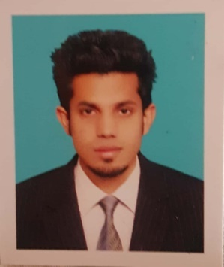
Objective

Seeking a career with a progressive organization where I can utilize my skills, knowledge and experience in project management, operations and finance in a challenging role that allows for advancement, growth and development whilst contributing to success and profitability of the organization

Experience

October 2016 to February 2018: ABACUS CONSULTING Customer Relation Officer

Main Responsibilities:
- Attracts potential customers by answering product and service questions; suggesting information about other products and services.
- Opens customer accounts by recording account information.
- Maintains customer records by updating account information.
- Resolves product or service problems by clarifying the customer's complaint; determining the cause of the problem; selecting and explaining the best solution to solve the problem; expediting correction or adjustment; following up to ensure resolution.

Achievements:
- Officially commended for initiative, enthusiasm, tenacity, persuasiveness, intense customer focus and dependability in performance evaluations.
- Completed voluntary customer service training to learn ways to enhance customer satisfaction and improve productivity.

Additional skills
- Successfully managing various on-going situations improved my problem solving skill.
- Being part of the teams of conference assistants helped me mature as a team-player.
- Working to tight deadlines enhanced my ability to work under pressure.

6 week internship BANK ALFALAH Internee

Main Responsibilities:
- To support financial reporting activities along with project involvement and company administration duties.
Achievements:
- With the help of internship my Practical experiences were increase in that industry i wish to work in.
- Experience of teamwork and development of interpersonal skills I have get in internship and it will help me in future.

Academics

2015 B.COM (Bachelor Punjab University Lahore Punjab Pakistan
In commerce)

2013 I.COM Board of intermediate and secondary education
Lahore Punjab Pakistan

2011 Metric (science) Board of intermediate and secondary education
Lahore Punjab Pakistan

Honours / Achievement

- Nominated for best student award at Punjab University.

Computer Skills

- Competent in MS Office applications
- Familiar with important windows operations
- Fast, efficient use of World Wide Web, Email and various online services

Personal Details

- D.O.B: 18-04-1991
- Nationality: Pakistani
- Marital Status: Unmarried
- Urdu and Punjabi (Native), and English (Moderate)

