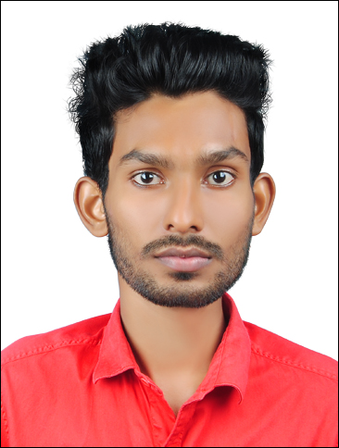 | CURRICULUM VITAE  SHAJEER
CONTACT INFORMATION  C/o 971501685421  shajeer.377453@2freemail.com  PERSONAL INFORMATION  Date of Birth Nationality Gender Marital Status : 02/04/1992 : Indian : Male : Single  PASSPORT DETAILS  Date of Issue Place of Issue Date of Expiry : 10/03/2016 : Cochin : 09/03/2026  VISA DETAILS  Visa Status Date of Entry Date of Expiry : Tourist Visa : 25/01/2018 :23/04/2018  LANGUAGES  - English  - Hindi  - Malayalam  PERSONAL SKILLS  - Strong Technical & Sales Skills  - Hardworking & Creative  - Quick Learner  - Disciplined & initiative  - Very good Interpersonal skill | OBJECTIVE :  To procure a challenging position in an innovative and progressive company where my skills and abilities can be utilized for my professional growth, the company’s benefit as well as to serve the whole of mankind.  EDUCATIONAL QUALIFICATIONS  COURSE INSTITUTION YEAR  Diploma in Electrical & Electronics Engineering Sree Rama Government Polytechnic College, Kerala 2016  Plus Two State Board of Vocational Higher Secondary Examinations 2010  Secondary School R.M. Vocational Higher Secondary School, Kerala 2008  TECHNICAL  Diploma in Advance Instrumentation and Control Attendantfrom National Council of Vocational and Research Training – Kerala.  COMPUTER SKILLS  Diploma in Computer Hardware Maintenance from G-Tech Computer Education, Kerala.  Diploma in MEP Design from CADD Centre Training Services, Kerala.  Advanced International MEP Designing & Drafting  WORK EXPERIENCE  Worked as a Computer Hardware Technician & Sales in Hi-Tech Computers, Kerala, India from 15.01.2011 to 30.12.2016.  Worked as a Graduate apprentice in Kerala State Electricity Board 110 KV Substation, Kerala, India from 19.09.2016 to 18.03.2017.  DECLARATION  I hereby declare that the above furnished information is true to the best of my knowledge and belief  SHAJEER

