arun.377454@2freemail.com C/o 971501685421

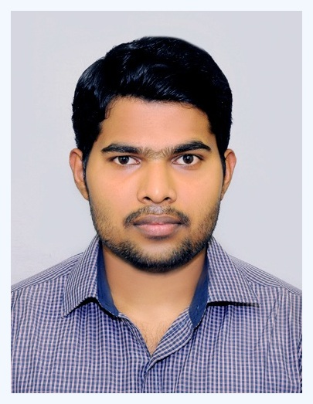

ARUN
SITE ADMINISTRATION
An achievement-driven professional targeting senior level assignments in Site Administration and Project Planning
Profile Summary
- A goal-oriented professional with nearly 3 years of experience in MEP Operations and Site Administration
- Proficient in monitoring all site related activities and ensuring their smooth execution as per project schedule with focus on optimum utilization of manpower & materials
- Excellence in coordinating with internal/external stakeholders involving top level management and govt. authorities for running successful projects; experience of implementing procedures and service standards for achieving business excellence
- Experienced in finalizing terms & conditions of contracts and settlement of agreements; ensuring that contracts are finalized within negotiated & agreed-upon parameters
- Skills in ensuring effective site management and discipline to ensure safety / hygiene and timely execution of projects in accordance with standards pertaining to machinery & equipment
- An effective communicator with excellent problem-solving, presentation and negotiation skills
Core Competencies  Site Administration  Fabrication & Erection  Design Engineering  Project Execution & Management  Materials Management  Process Improvement  Liaison & Coordination  Budgeting & Cost Control  Manpower management |  | Academic Details  - B.Tech. (Mechanical) from Mahatma Gandhi University, Kerala in 2015 with CGPA 7.95/10  Certifications  - IOSH level 3 in managing safely  - ASNT LEVEL-II Certification in the following  - Radiographic Testing (RT)  - Ultrasonic Testing (UT)  - Liquid Penetrant Testing (LPT)  - Magnetic Particle Testing (MPT)  - Certified First Aid Trainer  Trainings  - Industrial and Construction Safety from National Council for Technology and Training (NACTET)  - Quality Control and Inspection  - Power Plant Engineering  - Oilfield Engineering  - Piping Engineering  - Pipeline Engineering  - Welding Engineering  - Structural Engineering  - Ducting Engineering  Organizational Experience  Action International Services L.L.C., Dubai from Mar’17 – Dec’17 as Site Engineer  Key Result Areas:  - Working as a Site Engineer at Ground Water Control (GWC) department at Dubai  - Managing dewatering work of construction projects by deep well, well point and sump pump systems all around the Dubai  - Conducting requirement analysis, finalizing specifications, validating designs and reviewing detailed documents  - Providing consultancy on Project Planning, Execution and Management in tune with the core business objectives (including risk management, effort / time / cost estimation, and contingency planning)  - Coordinating for techno-commercial project activities and drawing specifications with the clients to ensure documents are per the specifications of clients
Skill Set

Change Agent
Motivator
Communicator
Collaborator
Career Timeline  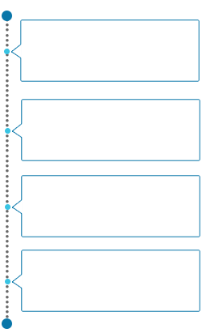  Jun’15 – Dec’15  Armstech Engineers Private Limited, Ernakulam, India  Jul’15 – Mar’17  Vikram Sarabhai Space Centre (VSSC) ISRO, Trivandrum, India  Dec’15 – Jul’16  Khodal Erectors Private Limited, Gujarat, India  Mar’17– Dec’17  Action International Services L.L.C., Dubai  Kalium, Dubai as Logistics & Supply Chain Consultant  Kalium, Dubai as Logistics & Supply Chain Consultant  Extracurricular Activities  - Participated and cleared assessment in HABC Level 1 & 3 international award in principles of health and safety  - Passed assessment for Permit to Work (PTW)  - Assisted in the making of Kerala’s first e-Panchyath, Pampakuda in Ernakulam district in Kerala  - Attended state level Work Experience Fair in 2006 & 2008  Technical Skills  - Solid Edge ST5  - Microsoft excel  - ASNT Level 2 | - Supervising operations including manpower & resource planning, material planning, finalization of vendors & manufactures as per client approval and procurement of electrical and mechanical items  Highlights:  - Merit of completing quality projects within time by taking material request, manpower request initiatives  - Implemented several measures to identify deformities, malfunctions or other abnormalities and safety and health problem identification in site.  - Instilled basic quality philosophies of doing things right the first time, resulting in an 50% reduction in company rework cost  Vikram Sarabhai Space Centre (VSSC) ISRO, Trivandrum from Jul’15 – Mar’17 as Apprentice Trainee at Non – Destructive Testing Facility (NDTF)  Highlights:  - Conducted radiographic testing (RT) & interpretation of raw materials, weldments, castings & other machined components (using computerized, digital and conventional methods) used in various stages of ISRO launch vehicles  - Performed Ultrasonic Flaw Detection Testing (UT) of various raw materials and flight hardware  - Assisted in the entire gamut of operations like ultrasonic thickness gauging & electrical conductivity measurements of metallic materials and Liquid Penetrant Testing (LPT) (using both dye & fluorescent methods) of weldments, castings & other machined components used in various stages of ISRO launch vehicles  Khodal Erectors Private Limited, Gujarat, India from Dec’15 – Jul’16 as Quality Control Engineer  Highlights:  - Performed fabrication, erection, alignment and qualification of lignite handling conveyor structure and roller-belt assembly  - Installed Mesh and Rail Type Cable Tray for supply lines, communication lines and so on  - Performed double layer insulation sheeting for control rooms, pump houses, ducting systems and conveyor structures  Armstech Engineers Private Limited, Ernakulam, India from Jun’15 – Dec’15 as Mechanical Engineer Trainee  Training  Organization: Fertilizers and Chemicals Travancore Limited (FACT), Ernakulam, India  Period: June 2014
Personal Details
Date of Birth: 19th June 1993
Languages Known: English, Hindi, Malayalam and Tamil
Nationality: Indian
Marital Status: Single
Driving License No.: UAE LMV and international driving license

