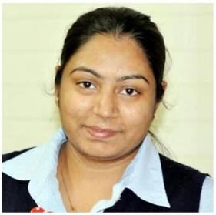
CURRICULAM VITAE
Amandeep
Mobile : C/o 971501685421
Email: amandeep.377475@2freemail.com

Qualification:
- 10th March 2001
- 12th March 2003
- Diploma in General Nursing & Midwifery (Adesh Institue of Nursing Mukatsar)
Sept. 2003 to Oct. 2006
Register Nurse Number : 33461
Register Midwife Number : 33472
- Diploma of hospitality (Perth College of Business & Technology) 5th Oct 2009 to 23rd Sept. 2011.
- Diploma of Business (Perth College of Business & Technology) Oct. 2011 to 9th Oct. 2012.
- Advanced Diploma of Business (Technical College of Western Australia)
Work Experience:
- Saran Hospital (Work as RN) Oct. 2006 to 5 Dec 2008
Reference : Dr. Labh Singh Sarn
Regd. No. E.O.23005

- St. John of God Healthcare (Employee)
Patient care assistant (Id No. 189036)
13 June 2011 to 21 Jan. 2015
Reference : Melanie Coutinho (Human Resource Officer) 0892479049

- Hender Care Nursing and support Services
Position : Assistant in Nursing and Patient care assistant
24-05-2012 to 20-01-2015
(Id. No. 1010756)
Reference : ANN Quirke (National Manager Nursing Service)
E-mail: anne.quirke@hendecare.co.au
Ph. 0863325001, 13009936

Responsibilities Handled

- Caring the patient 24 X 7.
- Manage the admission and discharging of patients.
- Interacting with the medical bodies in the hospital.
- Provide suggestions to family member and other staff on diseases.
- Provide assistance to Nursing Manager in the supervision of staff nurses.
- Maintain the patient charts.
- Provide training to the new recruiters.

Personal Details:

D.O.B. : 10-01-1986
Sex : Female
Status : Tourist Visa
Marital Status : Married
Languages Known : English, Hindi & Punjabi
Nationality : Indian
Religion : Sikh

Declaration:

I hereby declare that the above furnished information is true to the best of my knowledge.

Date....................................

Place...................................

Amandeep

