HATIM
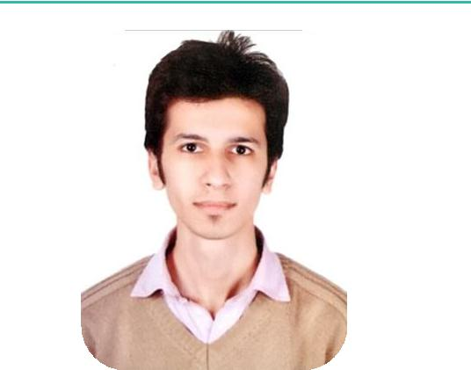

Hatim.377507@2freemail.com

C/o 971501685421

OBJECTIVE

To work in a challenging and growing environment and utilize my skills and abilities for organizational and self growth. To observe, learn and understand the core of Network administration and deliver required support efficiently and effectively.

SKILLS

Security software, ERP systems, Dassault, Cloud computing, virtual machines, postmaster, Microsoft office.

Devices- Biometric Machines, CCTV, Servers, Firewall, Apple devices, NAS systems, Routers, N- computing

PROFESSIONAL EXPERIENCE

LEAD NETWORK ADMINISTRATOR

METAFOLD ENGINEERING PVT LTD

ON PAYROLL OF NETLNK SOLLUTIONS

November 2014 - October 2017

Profile Summary:

Responsible for day-to-day network support communications & infrastructure architecture across all company locations. Performed multiple site visits for 3rd party vendors on behalf of Net LNK Solutions to provide quality network support and effective solutions.

Roles and Responsibilities:
- Troubleshooting network glitches and hardware related issues.

- Identifying system discrepancies and thereby proposing effective long-term solutions.

- Ensuring smooth functioning of hardware and strong network connectivity on all systems at all times

- Configuration of 3rd party vendor servers and creating a secured network.

- Successfully setting up system firewalls and point to Point connections for the entire vendor unit.
- Configuring CCTV cameras and biometric devices on vendor premises.

- Designed network security for 3rd party vendors.

- Procured hardware and software as per vendor requirement by negotiating best deals with dealers.

- Handled email server for sending and receiving incoming and outgoing emails.

- Responsible for troubleshooting of basic software’s in case of emergencies.

- Training to users for new software implemented.

- Configured NATing and virtual host on routers and firewall.

- Configured & install required digital devices for organization

NETWORK ANYLYST (TRAINEE)

NAFIS COMPUTER SYSTEMS

March 2013 - October 2014

Profile Summary:

Executed field work on behalf of Nafis system by performing multiple site visits to configure customer routers and inspect vendor infrastructure to provide network layout on client layout.

EDUCATION

BACHLORS IN COMMERCE Pune University

CISCO CERTIFIED NETWORK ASSOCIATE

Seed Infotech

MICROSOFT CERTIFIED IT

PROFESSIONAL

Seed Infotech
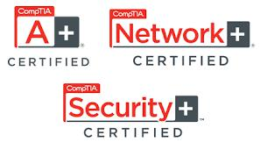

A+ N+

Disha Computers Institute

Extra Curriculum Activities:

- Attended Cancer awareness program organized by Rotary Club Pune.

- Volunteer at Indian Cancer Society.

- Attended seminars and webinars of cyber Security programs organized by Quick Heal Technology.

Roles and Responsibilities:
- Router setup and configuration.

- Troubleshooting network connectivity issues.

- Setup client printers and wireless devices on a secured network.

- Performed antivirus and spyware security setup on client desktops and laptops

- Cross selling of laptops and cyber security devices to customers on behalf of Nafis systems.

- 24*7 remote desktop support for clients in non-serviceable areas.

- Implementation of total network structure along with third party security software under supervision of Senior Network analysts.

- Proposing safety measures to clients on how to build a secure server room and data center’s in case of unforeseen circumstances leading to loss of valuable company data. Deployed third party software to secure data and backup.

- Configured p2p connections.

Configured Port forwarding and NATing on routing and firewalls.

HARDWARE AND NETWORK SUPPORT (INTERN)

DISHA COMPUTER INSTITUTE

July 2012 - January 2013

Profile Summary:

Executed and observed field work on behalf of Disha Computer institute under observation of trainers and professionals

Roles and Responsibilities:
- Basic router setup and configuration.

- Network cables troubleshooting.

- Assembling and of Desktop and laptop of various types and brands

- Print network setups and print media setups.

- Maintenance of digital devices.

- Project completions given by trainers.

- Implementations of basic network connectivity in lab environment.

- Lab setup.

- Deployed third party software to secure data and backup.

- Trained new students basic of computes and network.

- Was part of faculty as trained intern.

- Attended seminar for network career with senior trainers

- Worked on live computer labs of disha in case of breakdown.

