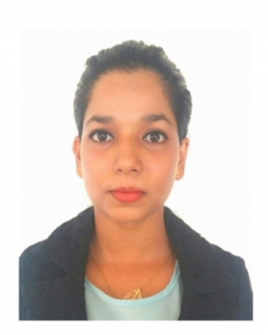Jenifer

DATE OF BIRTH 06/07/1993
E-mail: jenifer.377542@2freemail.com
Phone: C/o 971505891826

WORK EXPERIENCE
Herald Publications Pvt Ltd., Goa- India
September 2015 — November 2017
Senior office Assistant- Sales & business Development

Administration & back End support to the Sales & Marketing Team pertaining to supplying Data with reference to Revenues, Volume & Value Share in Competition with Market Analysis.
Generating Weekly, Monthly Revenue reports with regards to Sales growth pertaining to Region, Zone, Industry Etc.
Preparing Executive Daily Assessment reports/ Travelling Allowance Reports. Handling Clientele Database, with revenue & volume Tracking comparing year on Year Growth.
Monitoring Executives supplying data for Competition Data.
Understanding Market Trends interms of growth & volume share, also setting targets based on Industry growth levels.
Handling Marketing Audit queries & working in close relation with Accounts Department for following up with recoveries of the Sales & Marketing team. Maintaining Monthly attendance & leave records for the Sales & Marketing Team. Generating minutes of the meeting from weekly meetings held between Asst. General Manager of Sales & Marketing & the Executives.
Ensure sales team have the necessary resources to perform properly
Coordinating with National Executives for smooth flow of operations, also tracking business growth of National clients with comparison with past Database.
Develop sales strategies and plans to boost the sales volume.
Coordinating with external agencies such as advertising, public relations etc.
Co-ordination with Sub Editors & Editorial desks for timely Press Releases & Event coverage.

Westzone Group LLC, Dubai- UAE May 2015 — September 2015
Cashier
Cash Counter Handling. Customer Relations

Delta Corp Limited, Goa - India November 2013 — April 2015
Assistant Procurement Officer

Obtaining Quotations from vendors for timely update on market rates for supplies. Preparing Purchase/ Work Orders for different Marine Supplies from time to time. Marine Store Inventory Maintenance in co-ordination with Marine Manager & Chief Engineer incharge. CoordinationwithOperationshead&Accountsdepartmentforflowoffunds.
Verification of Marine Department ship staff salaries.
Maintaining petty cash accounts and ensuring timely fund supply for daily miscellaneous expenses.
Goa Coastal Resorts & Recreation
Pvt Ltd., Goa- India
Guest Relations Executive
Handling guests check in & check outs. Customer Relationship maintenance. Gaming & Casino floor inspection.
June 2013 — August 2013
Arranging airport drops & pick ups in co- ordination with Transport department.

DEGREES &
DIPLOMAS
Diploma in Computer Application (Year: 2009)
Diploma in Telly ERP 9 (Year: 2010)

EDUCATION QUALIFICATION
Bachelors of Commerce (B.com) June 2010 — May 2013
St. Xaviers College, Goa- India

Specialisation in Cost accounting & Taxation.

Higher Secondary School Education June 2008 — April 2010
St. Thomas Higher Secondary, Aldona, Goa- India

Secondary School Education June 2007 — April 2008
St. Xavier's High School, Moira, Goa- India

Insurance Advisor October 2017 — December 2017
Insurance Regulatory and Development Authority of India

INTERESTS Painting & listening to music

REFERENCES Reference available on request.

PASSPORT
Expiry date: 15/04/2024

