DR.AMBU 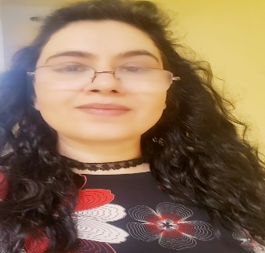
MOB- C/o 971501685421
Email ID- ambu.377573@2freemail.com
Dear recruiter:
As an experienced dentist, I would like to devise captivating, fascinating, and unique practices of dentistry that creates interest in the patient. With the help of my cordial nature, I would like to build good rapport with my patient as well as colleagues around me.
PROFESSIONAL :-DENTIST
RESUME—Looking for challenging assignment in dental/administration/
Management/clinical practice.
GENDER—Female
CITIZENSHIP –Indian
DATE OF BIRTH----15/6/1972
SUBJECT:-Core subjects>Dental surgery, Restorative dentistry, prosthodontics.
NAME OF THE CLINIC PRESENTLY WORKING AT : KUSH DENTAL CLINIC
EDUCATION – B.D.S.[Bachelor of dental surgery] 1992-1996
EXPERIENCE:- 1) Nearly 10 years of experience in different clinics in various post and area of dentistry.
2) worked as management in charge in LOK HIT HOSPITAL since 5.2.2007 to 16.4.2011
REGISTRATION NO.---3471/A
PROJECTS—Completed dental camps organized by clinic, actively participating in social awareness

EXPERIENCED---2009 onwards
---------Practiced in own 2 clinics in different part of GURGAON
--------Performed clinical assessment on patients and discussed
Treatment options and decided best suited treatment plan into
Account factors including time , cost,age and medical history of patient.
-------------examining, diagnosis, treating disease, abnormality , injuries and
dysfunctional disorder of oral cavity and its associate structures.
-----Worked with private hospital LOK-HIT DENTAL HOSPITAL AND RESEARCH
PVT LTD [5/7/2007-16/4/2011] as a hospital incharge and dentist as well.
---------contacted patient on hospital waiting list for dental treatment by
Appointment card or by phone .
------organized weekly pediatric session and performed procedure on children.
-------Developed excellent patient care skills learned through clinical practice.
SKILLS----ORGANISATIONAL—
----Managing appointment and treatment for own set of patients,
Experienced at working to deadlines
COMPUTER----Use of Microsoft, excel and powerpoint ,proficient use
LANGUAGE------ ENGLISH ,HINDI,NEPALIES,
Sincerely,
DR Ambu

