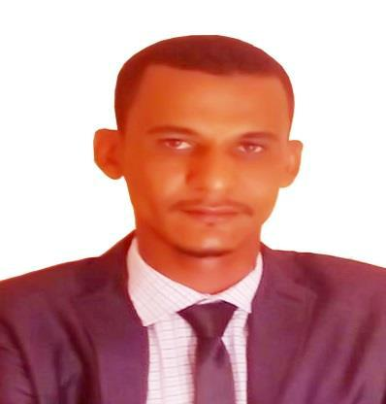
Gerenal Information

Name : Abdelrahim

Birth Day : June 1989

Citizenship : Sudanese

Contact Information

Alain, UAE

Tel : +971501685421

E-Mail: abdelrahim.377618@2freemail.com

Objectives

I Do Not Care To Work In Large Foundation Or Small , Only Which I Finding From Through It The Spirit Of Competition To Reach To Achieve The Goals .

Education

May 2017:

Mini Master Business Administration From Torontoy International University

With Grade Tow Class – Division One .

Nov 2015:

B.Sc In Mechanical Engineering (Power) From Sudan University Of Science & Technology With Grade Second Class – Division Tow .

Oct 2008:

Diploma 3 Years In Mechanical Engineering (Ref & Air Condition) From Sudan University Of Science & Technology With Grade Second Class – Division One .

1

Experience

- January 2016 Till May 2017 Company : Cool tech Engineerig .
Job Title : Project Engineer ( HVAC) .

Project : Aldawwa building

Madani Bus Station .

Bank OF Fisal Islamic .

Alfasher Power Station .

Sudan Khartoum Military Uniform Factory .

Cosmetics Factory (Soba) .

Job Description : Receipt Of Drawing From The Consultant , Project Pricing , Follow Up The Details Of The Project With Consultant , Prepare A Time Table For The Executed Of The Project , Review The Calculation Load & Shope Drawing & Submit Them To The Consultant , Supervision On Executed Works In Project From Start To Testing & Commissioning .

- Aprill 2011 Till Oct 2012: Company : Décor House Company . Job Title : Air-Condition Engineer .

Project : United Capital Bank (Presidency) .

Job Description : Supervision Of Building Which Include Units Internal

External , Such As : Fan Coil Unit , Chiller System , Air Handling Unit .

And

Operating Test, And Monitor The Performance Of The Units, Treating Any Defect In The Unit. Submit The Report To The Project Manager's Performance Air Conditioners .

2

- Sep 2009 Till Aug 2010

Company : Kyan For Tech.Air Condition & Cooling Com .

Job Title : Air-Condition Engineer .

Project : United Capital Bank (Industries Branch) , Jafar Ibn Auf Hospital For Children .

Job Description : Preview of the site and to identify units that inadequate. Doing The Installation Of Air Conditioners .
Sequent Maintenance For Air Conditioners, Emergency Faults ,Submititting A Reports To The Performance Of Air Conditioners .

- May 2008 Till Aug 2009 Company : Aswar Engineering . co.Ltd .

Job Title : Air-Condition Engineer .

Project : Helton Hotel .

Al Rebate University .

Army Tower .

Rosa Park Hotel .

Job Description : Supervision Of Building Which Include Units Internal And

External ,Such As : Fan Coil Unit , Chiller System , Air Handling Unit. Duct Spilled

Unit , Operating Test, And Monitor The Performance Of The Units, Treating Any Defect In The Unit. Submit The Report To Me The Project Manager's Performance Air Conditioners , electrical Wiring, Connecting Links Flexible, And Installation Of A Thermostat, Three Way Valve , Purchase Of Spare Parts And Equipment .

3

Training & Courses

30 July Till 03 August 2017

- Integrated Fire Safety System .

10 Jan Till 16 Jan 2017

- Marketing .

17 Jan Till 23 Jan 2017

- Human Resource Management .

24 Jan Till 30 Jan 2017

- Leadership Skills .

31 Jan Till 6 Feb 2017

- Strategic Planning .

7 Feb Till 13 Feb 2017

- Project Management Building (PMP) .

14 Feb Till 20 Feb 2017

- Business English .

21 Feb Till 27 Feb 2017

- Etiquette & Public Relation.

28 Feb Till 8 Mar 2017

- Financial Management . .

4

Nov 2011 Till Des 2011

- Training Course In Auto Cad (2d&3d) For Mechanical Engineering Covering All Theoretical And Practical Aspects Of The So –Called Program .

Des 2010 Till Feb 2011

- Diploma In Programmable Logic Control (Plc) System Covering All Theoretical And Practical Aspects Of The So –Called Program .

Nov 2007 Till Des 2007

- Diploma In Computer Science (Microsoft Office Applications) .

Languages

Arabic & English (Written & Oral) .

Other Skills

- HAP Software .

- Elite Software .

- Duct Sizer .

- Pipe Sizer .

- Car Driving .

- Ability To Work With Colleagues .

- Ability To Work Anywhere In Out The Country .

5

