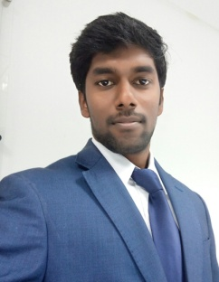
KARTHICK
Mobile No: C/o 971501685421
Email ID: kartick.377627@2freemail.com
Objective:
To pursue a challenging and growth oriented career is an organizational that offers opportunities to learn & grow by delivering the results.
Key qualification:
- I have one year experience as a Junior Accountant with the better knowledge of accounting tools, procedures and transactions.
- I have two years experience as an Admin Assistant. Seeking to work in a challenging environment and grow with the company to achieve its goals and additional knowledge.
Work experience:
- Worked as an Admin Assistant (Logistics) with Injaz Marketing Management (UNB), Sharjah, UAE for the period of from December 2015 to 6th Feb’2018.
Responsibilities:
- Provide general administrative and clerical support including mailing, scanning, faxing and copying to management.
- Assist in resolving any administrative problems.
- Coordinate and maintain records for staff office space, phones and office keys.
- Maintain office supplies for department.
- Perform data entry and scan documents.
Work experience:
- Worked as a junior accountant with Mani Marketing, Tamilnadu, India for the period of June 2014 to August 2015.
Responsibilities:
- Posting and processing journal entries to ensure all business transactions are recorded.
- Updating accounts receivable and issue invoices
- Updating accounts payable and perform reconciliations.
- Avoiding outstanding expenses and managing petty cash.
- Finalize the day’s balance and prepare and print management reports.

Qualifications:
Bachelor of commerce in accountancy from Thiruvalluvar University- 2014.
H.S.C from S.K.V.Hr.Sec.School- 2011.
S.S.L.C from S.K.V.Hr.Sec.School- 2009.
Computer skills:
Well versed in MS- Word, MS- Excel, MS- power point.
Certification in Tally ERP9.
Strengths:
- Hard Working, Punctual, Sincere and Good team player.
- Adaptable according to situation and Self motivator.
- Eager and fast learner.
- Good interpersonal skills.
- Well versed in Tally ERP9
Personal details:
Date of birth: 25/05/1994
Marital status: Single
Nationality: Indian
Knowledge of language:
English, Tamil.
Declaration:
I hereby declare that the information given above is true. And correct to the best of my knowledge. Reference available upon request.

KARTHICK

