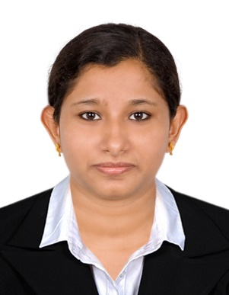
CURRICULUM VITAE

LEYA
Sharjah main city
UAE
E-mail: leya.377631@2freemail.com
Ph : C/o 971501685421

DHA Eligibility Number :DHA/LS/1032017/696822
MOH Evaluation certificate Number : 159435
► Objective
A highly motivated, confident individual with exceptional multitasking and organizational skills. Able to communicate effectively with patients to maximize the rehabilitation of patients and to ensure understanding of often complex clinical issues impacting on recovery.

► Qualifications
Professional Qualification:

M.P.T (Cardio Respiratory) from SaveethaCollege of Physiotherapy,Chennai, Approved by Saveetha University
Year of passing 2013.

B.P.T from UCA college of Physiotherapy,Chennai, Approved by Dr.MGR university,
Year of passing 2010.

► Professional Experience (Total Exp – 2years)
August 2014 To January 2017 :
MADRASS MEDICAL MISSION HOSPITAL, CHENNAI, INDIA.

AREA OF CLINICAL EXPERTIES

- Physiotherapy Department
- Orthopedics Pre-operative and post-operative.
- Cardiothoracic – ICU and Post op.
- Neurology and Neurosurgery department.
- General medicine unit,
- Gynecology and Obstetrics department.
- Outpatient department and rehabilitation department.
- Pediatrics and Neonatal ICU department.
- Project work including Clinical and data collection

► DUTIES AND RESPONSIBILITY
PRINCIPAL APPLICATION  - Ultrasound  - Transcutaneous electrical nerve stimulation.  - Interferential therapy.  - Traction machine.  - Wax therapy.  - Heat & Cold equipment.  - Continuous passive motion unit.  - Shoulder, Arm, Hand, Leg, Knee & foot exercise equipment’s.  - Suspension Aids | PROCEDURES CARRIED  - Providing a high standard of physiotherapy services to patients.  - Assess physical function, analyze findings and establish Physiotherapy diagnosis.  - Communicate with doctors about patient goals and care plan.  - Ensure safe equipment practice and use.  - Involved in ward rounds, meetings & case conferences.  - Organizing & prioritizing workload based on urgent referrals.  - Documentation of complaints /incidents and reporting.  - Documentation of patient’s treatment and progress.  - Educate patients on safe health practices and avoid Recurrences.

CONFERENCE AND PARTICIPATION

- South India Physiotherapy Conference Program,2009
- CME Of Hands on demo of techniques in stroke management,2009
- CPE of Myopathy, Ergonomics &Taping in physical Rehabilitation Program,2010
- Pulmo Rehab 2012.
- ICNR 2012.
- Syncon 2015

► Personal Details
Name | LEYA
Date of birth | 19/04/1987
Gender | Female
Languages known | English ,Hindi, Malayalam, Tamil
Marital Status | Married
DHA &MOH Eligibility Letter | Valid till may: 2018. MOH – Nov 2020
Visa status | Residence

► DECLARATION

I hereby declare that the above-mentioned details are true and correct to the best of my knowledge and belief

Leya

Place: Dubai Date:

