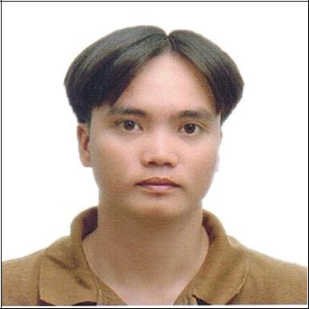
RAYMOND

Email | : Raymond.377632@2freemail.com
C/o-Mobile No. | : +971501685421
Citizenship | : Filipino (Foreigner)

Positions I can handle very well

- Precast Production Engineer
- Project Engineer
- QC Inspector

My Accumulated Professional Experience (8 years)

- 5 years and 10 months in Precast Industry as Production Engineer, monitoring progress in production of precast component.

- 2 years and 8 months in Water Line including Road Works and Tunnel work as Project Engineer/QC Inspector, implementation of construction plan, project monitoring, preparation of weekly & monthly progress report, evaluation of contractors billing.

Character Strengths

- Excellent leadership skills, gladly accepts responsibility.
- Look to the situation in a positive way.
- Mission oriented.

- Financial literate.
- Fast learner.

- Can work under pressure.

I have a degree in:

Bachelor of Science in Civil Engineering (Graduated 2007)

Licensed Civil Engineer (Professional Regulatory Commission – PH)

Bataan Peninsula State University (BPSU)
Balanga City, Bataan Philippines

Professional experience

Company

: Robin Village Development Pte. Ltd.
Tuas South Ave.1 Singapore 637282

(May 2012 – Present)

Position

: Site Engineer (Production Engineer)

Duties & Responsibilities:
- Control the production including issues and problem arises in production line.
- Ordering of materials for production but maintaining minimum stocks.

- In charge in arrangement of manpower and equipment needed.
- Prepare daily production schedule and casting report.

- Ensure the quality of product send to the client be in good quality and condition.
- Assist logistic team in delivery on site of the product.
- All other related duties instructed by the Production Head/ Manager.

Company Position

: Maynilad Water Services Inc. (April 2008- December 2010)

MWSS Compound, Katipunan Road, Balara Compound, Quezon City

: Project Engineer/QC Inspector, PMG-Construction

Duties & Responsibilities:

- Monitors project implementation and accomplishment of contractors.
- Prepares weekly/monthly project accomplishment report.

- Checks/validates contractor’s submittals/billing.
- Inspection of quality of works of the contractor

SEMINARS ATTENDED

Supervise Construction Work for Workplace Safety and Health Training Class No. 2018/041

Robin Neo, Fonda Global Engineering Pte. Ltd.

45 Sungei Kadut Loop Singapore 729495

Safety Awareness Seminar (April 2010)

Engr. Conrado P. Soriano, Head of Maynilad Safety and Security Department Maynilad Office, MWSS Compound, Katipunan Rd., Balara, Quezon City

Integrated Risk-Based Management Course (January 2010)

Daniel C. Dy, Senior Consultant of Linc International Management and Consulting Group Maynilad Office, MWSS Compound, Katipunan Rd., Balara, Quezon City

PERSONAL PROFILE

Date of Birth:

Age:
Civil Status:

Religion:

January 26, 1984

34
Married

Christian (Born Again)

