CURRICULUM VITAE

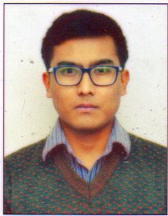

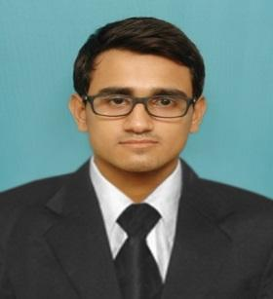
MANSAN
Phone: C/o 971501685421
E-mail: mansan.377684@2freemail.com

CAREER OBJECTIVE:
Devoting my potentials sincerely towards my work, learning the competitive advantage in the emerging scenario of hotel industries thus gradually reaching to an esteemed position of my goal.

AREA OF INTEREST: Food & Beverage Production / Bakery Deptt.
WORK EXPERIENCE: (2 years)

- Seventeen weeks Industrial Training in The Trident Oberoi, Chennai.
- 9 months Bakery Deptt Job Training in Savera Hotel, Chennai.
- 1 year Burger King Muscat Oman.

ACADEMIC PROFILE:

COURSE | UNIVERSITY/  BOARD | COLLEGE/SCHOOL | YEAR | %
B.Sc. H & HA | NCHMCT & IGNOU | Institute of Hotel Management, Chennai | 2014 | 1styr – 71%  2ndyr – 76%  3rdyr - 71%
Diploma in Skill Development\ in Bakery | NSDC | Don Bosco, Shillong | 2016
Higher Secondary | MBOSE | St. Edmunds College | 2011 | 50.2%
Secondary | ICSE | St. Edmunds School | 2007 | 64%

LANGUAGE KN0WLEDGE:

LANGUAGES | READ | WRITE | SPEAK
English | Fluently | Fluently | Fluently
Hindi | Fluently | Fluently | Fluently

PERSONAL PROFILE:
Date of birth: 02/09/1991
Nationality: Indian
Sex: Male
ISSUE DATE | 19/08/2014
EXPIRY DATE | 18/08/2024
Pass port Details:

STRENGTH PERCEIVED:
- Good Presence of mind
- Passionate
- Consistent Performer
- Strong Determination
- Self Confidence

Declaration
I hereby declare that all the information furnished above is true to the best of my knowledge and belief.
Place: Sharjah – UAE

Date: 17/02/2018

MANSAN

.

