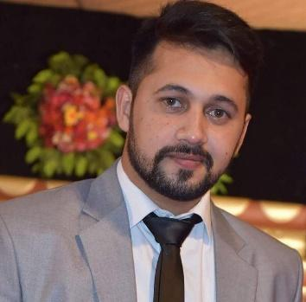
Shoaib
Deira, Dubai
Contact No: C/o 0501685421
Email: shoaib.377696@2freemail.com

Personal Profile

Date of Birth September 06, 1991
Nationality Pakistani
Marital Status Single

Career Aim
A highly efficient, results driven and capable marketing executive with a proven ability to effectively develop manage and control relationships between the company and its target audience. Having a proven track record of quickly understanding a marketing campaigns mission, vision and objective and then using the strong communication and negotiation tool to achieve sales targets. Enjoying challenging briefs & able to work to an excellent standard under considerable pressure whilst presenting a positive image to clients & colleagues. Now looking for a suitable sales position with a ambitious & exciting company.

Academic Background

- Pharm.D (2011-2016)
  - University of Sargodha, Sargodha, Pakistan.

- Intermediate (Pre-Med) 2011
  - BISE Lahore

- Matriculation (Science) 2008
  - BISE Lahore

Computer Skills

- MS Office
- Net Surfing and Browsing.

Experience

- Working as “Pharmaceutical/Medical Sales Representative” in “English Pharmaceutical Industries” from April 01-2015 to April 30-2016.

RESPONSIBILITIES
- Arranging meetings and appointments with doctors, nurses, pharmacists and other healthcare staff and make presentations to persuade them to prescribe company’s products.
- Delivering the samples to doctors of different categories and taking orders with regular follow-ups in order to answer the possible questions asked by them.
- Attending meetings, Conferences and training secessions beneficial to achieve the yearly and monthly sales targets.
- Keeping the record up to date and documentation and reporting the feedbacks gained.
- Liaise with and persuade targeted doctors to prescribe our products utilizing effective selling skills and performing cost-benefit analysis.
- Work with sales team to develop strategies and implement brand strategies to ensure a consistent marketing message.
- Implant strategies to promote the assigned products to influence targeted group in the decision making process.
- Monitor and analyze data and market conditions to identify competitive advantage.
- Keep accurate records and documentation for reporting and feedback.
- Pursue continuous learning and professional development and stay up-to-date with latest medical data.

Working as a “Assistant Product Manager” in “01 Cero-Uno Biologico Intnl. (Pvt.) Ltd”. From June 01-2016 to December 31-2017.
RESPONSIBILITIES
- Meeting existing clients and the potential customers in order to get their interests about the products manufactured my company.
- Providing presentations and Motivational speeches to the team members in order to achieve the monthly targets.
- Implant strategies to gain the business outcomes, within or outside the targeted premises.
- Create plans for whole year to generate the expected capital and presenting them in front of upper staff.
- Working upon pre existing potent customers in order to build the current and long term future goals beneficial for company.
- Accessing the risk management of product with in the market keeping safe sides.

- Assist product managers to help departmental heads in running the day-to-day sales operations of the company.
- Involved in product planning, testing, pricing and preparation of product guides.
- Evaluate the weaknesses and strengths of their competitors’ products.
- Stable the plans for the marketed products in order to save the product from competitor’s eye and marketing trends.
- Assist the Manager in promotion of the product under development by reviewing the market information gathered before the product to be launched and amend before launching.
- Monitoring and accessing the launched product and getting people’s response to the product.
Volunteering
- Working as a volunteer and Ambassador in Event organized by IJT Pakistan.
- Working as a volunteer in
“Akhuwat” Foundation an NGO.

LANGUAGES
Fluent in English, Urdu and Punjab. Arabic writing and reading
Hobbies
Volunteering, Coin Collecting, Reading Books, Singing, Watching Movie, Snooker and travelling.
Reference:
Shall be furnished on demand

