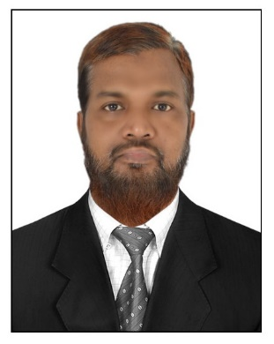
Objective

To work in a stimulating and challenging environment that would
facilitate the maximum utilization and application of my broad skills and expertise.

Summary of Qualifications

Result oriented, Proactive and Industrious professional with around 20 Years of extensive hands on experience in the areas of Administration, Human Resource Management, Training & Development and Process management among others

- Demonstrates an ability to analyze issues, expedite innovative solutions and consensus-driven environment that contributes to smooth operation and flawless functions at multiple locations to best of satisfaction of stake holders;
- Focused on superior performance and gaining credibility; Involved in the strategy, client advisory, recommendations and solutions
- Establishing strategic partnerships and relationships; Articulate with vision and passion; ability to work both in collaborative and independent work milieu; highly trustworthy, ethical and discreet

CORE COMPETENCIES

- Recruitment
- Performance Management
- Policy Administration
- Process Management
- HR Generalist
- Training & Development
- Employee onboarding
- Compensation and Benefits Administration

CAREER HIGHLIGHTS

- Reduced employee turnover by 20% through implementation of incentive plans.
- Designed and implemented the self-assessment mechanisms for team members.
- Recruited and trained the required manpower in the field of sales & marketing and other areas of operation
- Introduced the concept of kaizen and ensured the active participation of all team members in the drive.
- Designed an enterprise level automation solution and led a team of programmers for its development and implementation.
- Led “Surpass the Limits” drive which helped the functional units in improving the performance and productivity.
Employment History

NTIER Softwares (2013 – Till Date )
Manager – HR and Administration
Key Deliverables
- Responsible for end-to-end recruitment lifecycle.
- Responsible for Manpower planning and budgeting.
- Ensuring strict implementation and administration of policies.
- Formulation of processes and procedures within the policy framework.
- Identifying training needs and mapping of skills required for different projects and positions.
- Responsible for performance management and appraisals.
- Manage day-to-day HR and Admin operations
- Conflict management
Al Jabal Group Of Companies, Yemen (2000 – 2013)
Sr. Manager – HRM & Administration
Key Deliverables
- Managed the day-to-day operational and tactical aspects;
- Worked on improving operational systems, processes and policies in support of organization mission.
- Ensured strict implementation of policies and procedures in delivery and other aspects of operation.
- Responsible Training Need Analysis, conduct and evaluation of training programs for team members.
- Participated in all programs relating to performance evaluations and career development planning
- Identified areas for internal improvement and develops plans for implementation
- Reviewed the status reports of team members and addresses issues as appropriate

Aptech Limited, Eastern region, Bhubaneswar (1999 - 2000)
Regional Operation Support Executive
Key Deliverables
- Monitoring the operation in all the 68 centres in the region by analyzing reports, conducting meetings, open houses for stake holders and corporate clients and audits.
- Mentor through formal channels; Review evaluations within practice for consistency.
- Assess training needs and selects training tools for team members.
- Coordinated with stake holders on conduction of various activities, seminars and meetings

Corporate Business Group, Aptech Limited, North Zone, Delhi (1994 - 1996)
Training coordinator
Key Deliverables
- Initiation and conduct of the corporate trainings
- Understanding the skills training requirement of corporates
- Coordinate training programs and Formulating training module

Academic Profile
- MBA (HR)
- B Sc (Physics, Chemistry & Mathematics)
Personal VITAE
- Date of Birth: 15/06/1968
- Nationality: Indian
- Languages Known: English, Oriya, Hindi, Urdu and exposure to Arabic
- VISA Status: Visit Visa (expiring on 24th April 2018)

