Shahab  Dubai, UAE  Cell: C/o 971502360357  E mail: shahab.377712@2freemail.com | 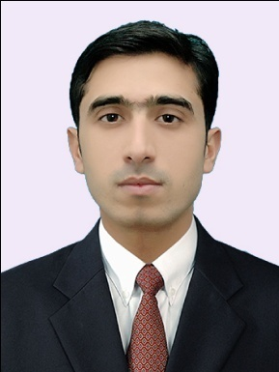
SUMMARY

- Over two years experience in IT field.
- Comprehensive knowledge of Microsoft Windows configuration, Active Directory and Windows Services Configuration.
- A confident and reliable IT Professional with extensive practical experience of working with computers and resolving any support issues that are raised to the service desk. Possessing a proven ability to administer and control the operation, configuration and maintenance of computer based information systems, as well as having an eye for detail and able to multi-task under pressure. An excellent communicator can relate well with people at all levels and has the flexibility of working well as part of a team and on my own.
- Now looking to further an already successful career by working for an ambitious and expanding company.

WORK EXPERIENCE

NetHome System Institute and IT Solution

- Worked as a System Administrator in an IT Training and Solution Company based in Pakistan from September 2015 to 2017 December.
- Install & upgrade PC hardware, software, and peripheral components as required.
- Perform troubleshooting to isolate and diagnose common PC problems.
- Provide users with desktop hardware and software technical support.
- Respond to the needs and questions of users concerning their use of desktop software and hardware.
- Evaluate software and hardware to be deployed in desktop environment.
- Provide basic instruction to end users on desktop software when necessary.
- Evaluating, testing, and implementing new devices and technology in a company.
- Effectively handling a number of situations and problems that require IT support, all at the same time
- Arranging new user accounts, password, email inboxes, and other services needed by new employees in a company
- Helping users understand and get accustomed to working with new software or technology.
- Evaluating whether the problem requires resolution, repairs, or replacement.
- Keeping server systems functioning smoothly.

SKILLS
- I have very good configuration, troubleshooting and verification Windows server deployment.
- Managing User accounts using Active Directory.
- Hardware installations
- Software installation
- Virtualization (ESXI server)
- Capable to work on MS Office 2003/2007/2010/2013
- Operating Systems and Application Softwares installation
- Server 2003/2008/2012/2016 (R1/R2).

QUALIFICATION

- BS Information Technology 4 years
- One year Diploma in IT

MICROSOFT CERTIFICATION

- Microsoft Certified Solutions Associate (MCSA)
- Microsoft Office 2013

PERSONAL INFORMATION

- Date of Birth: 3rd February 1993.
- Nationality: Pakistani
- Languages: English, Urdu, Pashto
- Currently on visit visa.

REFERENCES
Will be provided upon request.

