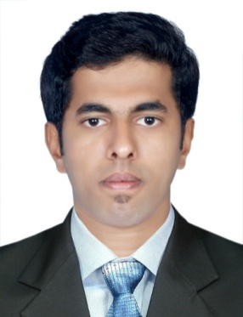
SHAVAN

Mob: C/o 971501685421
E-Mail: shavan.377746@2freemail.com
Applying for the post : Civil Site Engineer
Experience : 2 years 8 months
CAREER OBJECTIVE
A dynamic professional with in-depth experience in construction and building work. Currently looking for a civil engineering job position with a progressive construction company where my skills and experience will be fully utilized.
WORK EXPERIENCE

PROJECT IN OMAN (JAN 2016 – DEC 2017)

Organisation : DOLPHIN TRADING & INVESTMENT L.L.C, MUSCAT, OMAN
Job title : Civil Site engineer
Responsibility : Site inspection and Supervision
Project involved : ROYAL OMAN POLICE (UAE-OMAN BORDER POST COMPLEX)
Budget : 13 million OMR
Description : Includes 2 Customs stores, 1 Customs building, and 1 Light vehicle
shed, 1 Heavy vehicle shed, 4 Service yards, 2 Immigration buildings,
a 97m Link Bridge connecting the 2 Immigration buildings,
1 Transaction building and 18 Light and Heavy vehicle booths and
3 Guard Houses

PROJECT IN INDIA (MAY 2015 – JAN 2016)

Organisation : PUBLIC WORKS DEPARTMENT (PWD), KERALA
Job title : Civil Site engineer
Responsibility : Site inspection and Supervision
Budget : 20 million INR
Project involved : Quarters for Railway employees and maintenance of
Vypin Light House, Cochin, Kerala.

SKILLS AND ABILITIES
- Meet the clients, engineers & consultants to better understand the requirements.
- Setting out project works in accordance with drawings & specifications.
- Planning and management skill.
- Effective implementation of job.
- Critical Thinking and Decision Making
- Regular reporting to the project manager regarding the work schedule.
- Coordination & follow-up with sub-contractors for scheduling the tasks etc.
- Using IT in design and project management, specially software package such
as Auto CADD

EDUCATIONAL CREDENTIALS

- B.Tech in Civil Engineering from Cochin University of Science And Technology in 2015
with an aggregate of 75%.
- AISSCE in 2011 with 78%.
- AISSE in 2009 with 89.4%.

OTHER CAREER ENHANCEMENTS

- Autodesk AutoCAD
- MS Word, Excel and PowerPoint

PERSONAL DOSSIER
Date of Birth : 22th January 1993
Sex : Male
Nationality : Indian
Passport Detail : (Valid till 25/06/2025)
Languages Known : Fluent in English and Malayalam.
Converse comfortably in Hindi and Tamil.
UAE Driving License : No

