Career Objective  Customer Service and Administration- To have a growth oriented, challenging career where I can contribute my knowledge and skills to the organization and achieve more professional experience through continuous learning and teamwork.  Academic Qualifications  2012 - 2015 Bachelor of Business Management  Bangalore University  Total Marks Scored: 70%  2010 - 2012 Higher Secondary – Commerce  Central Board of Secondary Education  Total Marks Scored: 80%  2008 - 2010 Secondary School  Kerala State Board of Secondary Education  Total Marks Scored: 73%  Work Experience  - Customer Service Executive and Administrator at AL KARAMA MEDICAL FITNESS CENTER Dubai UAE.  (OCTOBER 2015 - OCTOBER 2017)  - Attend walkin customers  - Accept cash and do online payments  - Receptionist  - Call center  Strengths  - A self-motivated professional  - Skilled at balancing and prioritizing multiple tasks  - Effective in engaging all organizational levels  - Highly organized and able to prioritize effectively  - Flexible and adaptable to changes  - Excellent interpersonal skills  - Highly organized and able to prioritize effectively  - MS Office proficiency | 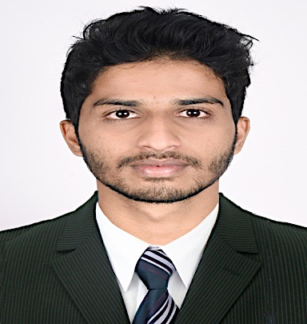  HIJAZ  Hijaz.377761@2freemail.com  MOBILE: C/o 971501685421  Permanent Address:  Dubai  United Arab Emirates  Personal Data:  Date of Birth : 5th Sep 1993  Sex : Male  Nationality : Indian  Marital Status : Single  Languages : English, Hindi, Tamil  Malayalam, Kannada  Arabic(Read,Write,Type)  Visa Status : Visit  Visa Expiry : 31/03/2018

