CURRICULUM VITAE
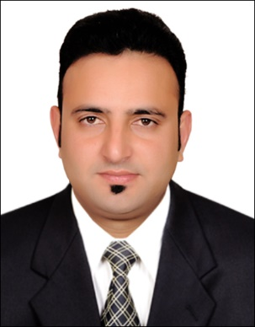
PERSONAL DETAILS
Name : ARSLAN
Nationality : Pakistani
Date of birth : 15-08-1989
Marital status : Married
Mobile number: C/o 971501685421
Email: arslan.377771@2freemail.com

LANGUAGES:

- ENGLISH – Fluent (written and spoken)
- ARABIC – Native (Read and righting)
- URDU - basic/advanced/fluent/native (written and spoken)

WORK EXPERIENCE:

Organization : | Coca-Cola Beverages Pakistan Ltd. (Rawalpindi)
Organization Type : | FMCG
Designation : | Sales & Merchandise Officer
Tenure : | 2009 to 2011

Organization : | ALMARAI COMPANY L.L.C
Organization Type : | FMCG
Designation : | Salesman
Tenure : | 2012 till date

EDUCATION:

INTERMEDIATE , Rawalpindi

KEY SKILLS:
- Good communication and interpersonal skills
- Good time management skills
- Ability to work under pressure
- Creativity in solving problems
- High commitment in team work

ADDITIONAL SKILLS:

- Valid UAE Driving License
- MS Office
- MS Excel

REFERENCES:

Available on request.

