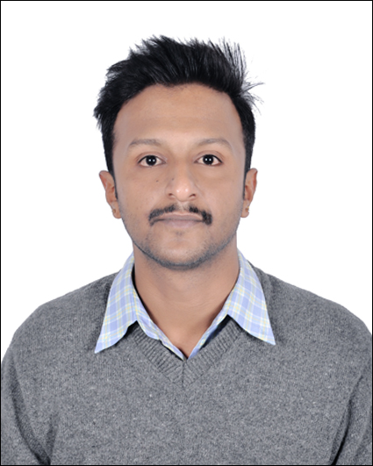
Suraj

Business Development Sr.Executive with broad background in operations, project and risk management. Enthusiastic team player dedicated to process improvements and staff development.
With Sales experience of 7 years and having promoted a variety of consumer products in United Kingdom [UK] and Australia [AU], I have created a niche for myself in this field. I have the talent to develop business strategies, oversee sales management, and bring in new and creative promotional methods to overshadow competitors

EMPLOYMENT

04/2016 - present SR. Business development executive & support trainer –
Dot Mappers – [Bangalore, Karnataka]. Traffic Radius - [Australia]
{B2B SALES OF SEARCH ENGINE OPTIMIZATION & WEBSITES}

• Maintaining fruitful relationships with existing customers
• Following up new business opportunities and setting up meetings
• Provided training to new employees and internal/external clients on effective
quality call handling and business etiquette.
• Planning and preparing presentations on the product portfolio, sales approach,
sales platforms and phone systems.
• Successfully managed a team of 22 outbound calling representatives and
provided constant feedbacks
• In charge of development and implementation of a customer service
department

07/2015 – 03/2016 Team leader–
Bemak Info Tech – [Bangalore, Karnataka]. Direct mobiles - [UK]
{B2C SALES OF MOBILE PHONES & INSURANCE}

• Monitored calls and transactions exchanged with external customers
• Manage the flow of day-to-day operations
• Monitored and reviewed agents and supervisors performance
• Exceeded sales goals by at least 40 % for 3 quarters in a row.
• Assist with placement of orders, refunds, or exchanges.

07/2013 – 06/2015 sme & group leader –
Ways 2 Save- Bangalore, Karnataka. Energy helpline - [UK]
{B2C SALES OF GAS AND ELECTRICITY}

•Create an inspiring team environment with an open communication culture
• Set clear team goals , delegate tasks and set deadlines
• Monitor team performance and report on metrics and involved in feedback
• Assumed ownership over team productivity and managed workflow to meet or
exceed quality service goals.
• Facilitated training and development programs for existing agents

08/2010 – 07/2013 Customer service representative & sme –
Selfinity Solutions- Bangalore, Karnataka, Energy Savers - [UK]
{B2C SALES OF INSULATION PRODUCTS}

• Make outbound customer calls to promote and sell a product or service.
• Create, maintain and update database of customers with complete information and emails.
• Ensure customer follow-up all the time.
• Send or email product literature, brochures, catalogs and other campaign material.
• Maintains accurate daily record of sales in sales tracker.
• Spend 30 minutes to one hour monitoring the agent

EDUCATION

2017 Dr. CV Raman University - Bangalore –
Bachelors in Computer Application

2010 V.E.T B.V.L Polytechnic – Bangalore –
Diploma - Electronics and communication Engineering

2007 Vivekananda Educational Center –
Karnataka Secondary Educational Board, SSLC

Skills

Communication & Interpersonal
Negotiation & Persuasion
Customer Handeling
Upselling
Decision Making
Team Management
Analytical Skills
Technical knowledge
Coldcalling

Personal Info

Address Union,Dubai
Visa Status Visit
Phone C/o 971501685421
Citizen Ship Indian
Email suraj.377785@2freemail.com
Date of Birth 05/09/1990
Place of Birth Bangalore
Languages Known ENGLISH, HINDI, KANNADA, TAMIL AND Telugu

Achievements

2017 REWARDS AND GOODIES–for meeting targets consistently
2016 REWARDS AND GOODIES–for meeting targets consistently
2015 BEST PERFORMANCE (TA) – Sales and Quality
2014 BEST PERFOMER OF THE YEAR – Sales
2013 BEST PERFOMER OF THE YEAR – Quality Date of Birth
2011 BEST SALES Team
2010 BEST SALES PERSON

Declaration

I here by declare that the information given above is true to the best of my knowledge and belief.

Date: Regards
Place: Suraj

