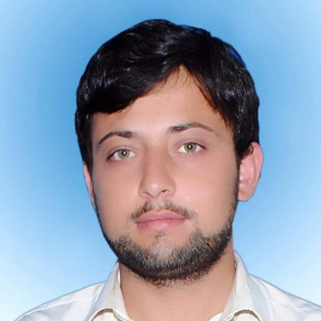
RESUME

Malak
Malak.377852@2freemail.com
Mobile: C/o 971502360357

Objective

Seeking a suitable position in accordance with my professional experience, qualification & skills gained over the years to the full extends for development, there by contributing to the overall growth and profitability of the organization as well as attaining self-growth in career.

Profile

Self- motivated ambitious and hardworking with zeal for professional progress and career advancement

WORK PROFILE
Through determination and dedication.

- Excellent team player and with result oriented
- Excellent interpersonal and communication skills
- Dedications, sincere & working are base
- I work well as a team member and adapt easily to new situations
- I am responsible, considerate
- I am hard worker and quick learner.
- Punctual, organized and systematic

COMPUTER SKILLS

MICROSOFT CERTIFICATION

- MCSE Infrastructure Administration: From Microsoft
- MCSE 2012 Severs Datacenter.
- MCP (Microsoft Certified Professional)
- MCSA (Microsoft Certified Solution Associates)
- MCSE (Microsoft Certified Solution Expert)
KEY SKILLS:

- Ms. Office 2013.
- Windows Server 2003/2008/2012 Installation & Configuration.
- Active Directory & DNS Configuration
- LAN Administration, Software Installation and updates.
- Hardware Installation, Troubleshooting
- Daily backup and configuring servers.
- Cisco Routers and Switches Configuration.

DESKTOP ADMINISTRATOR:

- Well known about client operating system installation, configuration and member of domains.
- Windows 7 (Ultimate and Professional 32 bits/64 bits)
- Windows 8.1 pro
- Windows 10.
- User Account Management.
- Disk Management.
- Administrator Password Backup.
- User Parental Control.

Work Experience

SYSTEM ADMINISTRATOR/ENGINEER:
NSIT System (Network System and Information Technology) (DEC 2015 to date)
Work Detail
Install, configure, and maintain AD, DNS, File Server, DHCP Server, FTP Server, Print Server etc. Installing & Configuring Windows 2008 & 2012 Server, Exchange Server 2010, TMG and Virtualization. Administer network workstations, utilizing TCP/IP networking protocols and Windows based operating systems.
Configure and Troubleshooting CISCO Routers, Switches and Access Point (Wireless device)

EDUCATIONAL QUALIFICATION

- 2017 : BS Computer Science from Sheikh Zayed Islamic Center University of Peshawar Pakistan.
- 2012 : Intermediate (Pre Engineering) from BISE Swat.
- 2010 : SSC (Science) from BISE Swat.

Languages Known
- English, Hindi , Urdu and Pashto

personal profile

Date of Birth : 02/06/1994
Gender : Male
Place of Birth : Buner
Nationality : PAKISTANI
Marital status : single
Religion : Islam
Visa Status : Visit Visa
Date of Expiry : 09/11/2022
Declaration
Taking the above mentioned which are correct to the best of my knowledge, if I am given a chance to serve in your esteemed organization, I assure my best service at all times and at all levels
(Malak)

