Abdullah

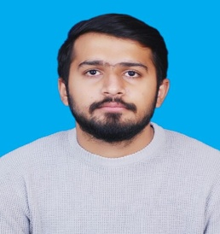

PERSONAL PROFILE:

CNIC: | 34603-5699867-1
D.O.B: | 05-06-1994
Mobile no: | C/o 971502360357
Email: | abdullah.377886@2freemail.com

OBJECTIVE:
To work in a competitive environment of an organization as Professional graduate that effectively utilizes my Analytical, Interpersonal, and Organizational Skills to gain practical and hands on experience of all manufacturing and Industrial Management skills of my Graduation theoretical course work.

EDUCATION:

Bachelor of Science in Computer Science | CGPA: 2.20 | Sep,2017
The University of Lahore, Lahore
Intermediate (F.Sc. Pre-Engineering)
Superior Groups of Colleges | Grade: C | Aug, 2012
Matriculation
City Public School | Grade: A | June,2010

PROJECTS:

- Design and Implementation of E-delivery system Website (Final Year Project)
- Football Club Web Site (Web Engineering)
- Packet Tracer (CCN)
- Scientific Calculator (Computer programming)

PROFESSIONAL SKILLS:

- Accomplished 03 months internship at Green Coast Company, UAE and observed administrator and networking scenarios in deep detail .
KEY SKILLS:

- Provide an Optimum Solution of problems within the assigned time.
- Effective Communication, Technical Report Writing & Presentation Skills.
- Quick grasping power, Leadership, Project planning & Implementation.

COMPUTER SKILLS:
- Microsoft Office
- Red Hat Linux
- PHP
- DEV C++
- Packet tracer CCN

CO-CURRICULAR ACTIVITIES:

- Participated in Annual Sports Gala arranged by authorities of UOL 4 consecutive times in a row (Won 4 gold medals in Football in these events)

.

