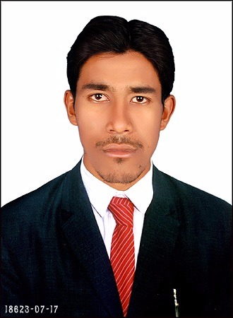
Shaik

Mail: - shaik.377903@2freemail.com

C/o-Mobile: +971501685421

Career Objective: -

Seeking challenging work environment that encourages continues learning, with an opportunity to participate and contribute in the fast growth of the organization.

Professional Experience: -

- 2 Years of Experience as Office Boy GLOBAL CONSTRUCTION AND ARCHITECT- ADILABAD-INDIA (2014 to 2015)
- Currently working as Meeseva online job work.

Job Description: -

Deputed tooversee all activities relevant to windows operating system and design, installation, configuration, administration and troubleshooting of LAN/WAN infrastructure and security. Setting up new user’s accounts and profiles and dealing with password issues. Investigating, diagnosing and solving computer software and hardware faults.

Roles &Responsibilities: -

- To manage and organize overall papers and files.
- To type down necessary papers for the office.
- To respond all the calls very sincerely and respectfully.
- To respond any basic query of visitors.
- To be capable of managing complex and multifaceted tasks.
- To schedule meetings and appointments with effective time management skills.
Skills: -

- Operating System : Microsoft Excel & Microsoft Word
- Programming in DCA & PGDCA.
- Well Verse with MS Access and P.Point.

Educational career: -

Pursuing B.Com (Computer’s) from “Vaghdevi College Nirmal.
Intermediate (H.E.C.) Board of Intermediate Education from Govt junior College,
Khanapur .(2011 - 2013).
SSC Board of Secondary Education from Govt High School, Khanapur.

Hobbies: -

- Internet Surfing.
- Reading Books & Daily News Paper
- Listening Music.

Personal Profile: -

- Date of Birth - 15th october, 1996

- Sex - Male

- Languages known - English,Urdu,Hindi,Telugu

- Nationality - Indian Muslim (Single)
- Visa Status - Visit Visa

