CURRICULUM VITAE
FAIZAN
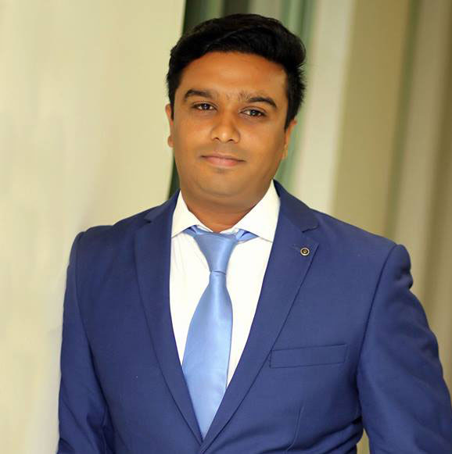

C/o- +971504973598

Faizan.377910@2freemail.com

Visa Status: Visit visa

Objective | To join an organization which helps me to enhance my professional capabilities and knowledge to do better work for the organization and establishes my career.
Experience | 2 Years Working Experience as an Accounts and Operations Coordinator  In Sites Power Training Institute Sharjah UAE  Accounts  - Maintain Cash Book / Bank Book  - Maintaining of Accounts Receivable/ Payable and Credit Control  - Updating registrations daily  - Update and Maintaining stock  - Monthly Financial Statement  - Internal Audit  - Daily Cash/check Deposits  - Monthly Attendance report  Administration/ Customer service  - Attending calls  - Assisting clients  Operations  - Making schedules  - Enroll students  - Forecasting  - Updating students registrations on server  - Preparing schedules  1 Year 2 months Working experience as an assistant sales and Accountant in Al Burkan Machinery and Heavy Equipment, Dubai.  - Maintaining of cash book/bankbook/bank reconciliation statement  - Maintaining of accounts receivable, accounts payable and credit control  - Preparing and updating sales accounts and cash control  - Update and maintain stock  - Monthly Financial Statement  - Internal Audit
Academic Record | MBA (Finance) 2012  Major  Financial Accounting  Financial Statement analysis  Financial Management  Principle of Management
B.Com IT (2008)
University of Punjab – Pakistan.
Major
Cost Accounting
Financial Accounting
Advance Accounting
Commerce
Banking
I.C.S (2005)
(Mathematics/Physics/Computer Science)
Government SIIT College of Commerce, Sialkot.
Board of Intermediate & Secondary Education, Gujranwala.
Short Courses | Business English Intermediate (2015)  Three-month short course for Business English.  International Computer Driving License (ICDL 2015)  Three Month short course for International Computer Driving License.
Internship | - Six to eight weeks internship in Soneri bank  District: Sialkot. Pakistan  Address: Main branch Shahab Pura road.  - 2 months of Internship in Starpak martial art and gloves PvtLtd. As a billing assistant in theaccounts department.  Wazirabad road Sialkot.
Computer Skills | - ICDL Certified Tester  - Proficient in M.S. Word, M.S. Excel, M.S. PowerPoint  - Quick book, Peachtree, Tally Accounting software  - Assembling Win 2007, Windows 8, Windows 10  - Internet Browsing & E-mailing  - Typing Speed 27TO 35 WPM
ICDL Certified | ICDL Certified Tester (2015)
Personal Information | - Date of birth: 14-JAN-1987  - Marital Status: Single  - Religion: Islam  - Nationality: Pakistani
Interests/  Activities | - Computer  - Accounting study  - Traveling  - Social Activities
References | - Will be furnished on demand.

