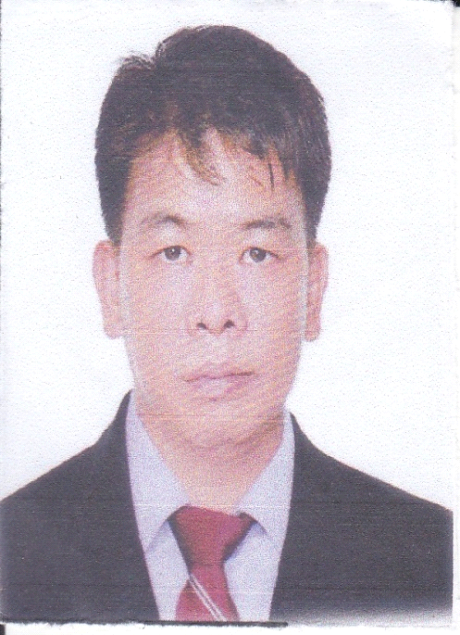LAURENCE
DUBAI UAE
Mobile # C/o 971501685421
Email: Laurence.377926@2freemail.com

CURRICULUM VITAE

CAREER OBJECTIVES
Energetic and motivating leader with proven ability to effectively manage both personality and projects.Self starter and strong independent worker. Excel at analyzing procedures to generate new ideas to improve efficiency and production quality, highly adaptable for overchanging circumstances.

SUMMARY
Lead carpenters with 12.3 years in the Carpentry trade. Including doors, windows and cabinets. Energetic carpenter specializing in house remodel and fence repair for residential homes. Lead Carpenters knowledgeable in all areas of Revit Architecture, Autocad 2007 and Revit MEP. Experienced journey man carpenter with morethan 18 years in variety of construction environments, embraces challenge by remaining flexible. Expertly trained in maner construction.

HIGHLIGHTS
•LOG HOME CONSTRUCTION
•BLUE PRINT INTERPRETATION
•FLOORING CONSTRUCTION
•FORM SYSTEM KNOWLEDGE
•GENERAL LABORER

ACCOMPLISHMENTS
Led a crew of 12.3 years carpenters in deck, wall and roofing projects. Mentored over 2 years junior level carpenters. Set up and erected scaffolding to the heights of up to 15 feet. Rapidly advanced to Lead Carpenter from a General Labor Position

WORK EXPERIENCED

Date : September 15, 2017-February 16, 2018
Company : Smart Idea Carpentry
Position : Foreman
Duties and Responsibilities : Supervise the Carpenter and Cutting Lists

DUTIES & RESPONSIBILITIES
Supervising and helping the Carpenters to make the project done faster and easier. To determine measurement and dimension. Installed cabinets, Base cabinets and moldings work independently on projects and task within a Carpentry Team Set windows and layouts for stairs and common raffers. Calculated accurate materials, estimate operated power tools, planers, jointers, skill saw, chain saw, router and pneumatic equipment. Consistently constructed projects that were squared and level. Cut and installed stair cases.

Date : October 30, 2014- ju;y 01 2015
Company : P & B Valises etCompagnie, Inc.
Position : Carpenter

DUTIES AND RESPONSIBILTIES

To make any kind of cabinets and wood products according to the company plan. Renovate and maintained older properties. work as a carpentry team in a task. Improved a product quality that is needed by using own plan.

Date : April 15, 2014- June 15, 2014
Company : Voice of America(VOA) Camp John Hay Baguio City
Position : Leadman Carpenter

DUTIES AND RESPONSIBILITIES

Installed floor joist, trusses and rafters. Repaired and maintained older properties, including renovating flooring, walls and ceiling, installing fixtures and remodeling bathrooms and kitchens. Cut timber, panels and other materials according to measured dimensions. Removed tool marks and surface adhesives after installation to improved project quality.

Date : September 13, 2001-up to present
Company : Inex International Expertise. Dubai branch
Position : Leadman Carpenter
Duties and Responsibilities : Examined buildings and projects specification

DUTIES & RESPONSIBILITIES

To determine measurements and dimensions. Installed cabinets, Base cabinets and moldings work independently on projects and task within a Carpentry Team. Set windows and layouts for stairs and common raffers. Calculated accurate materials, estimate operated power tools, planers, jointers, skill saw, chain saw, router and pneumatic equipment. Consistently constructed projects that were squared and level. Cut and installed stair cases.

PERSONAL INFORMATION
Nickname : Louie
Civil Status : Married
Date of Birth : December 19, 1973
Height : 5’6
Weight : 150 Lbs
Body Built : Average
Skin Complexion : Fair
Religion : Roman Catholic

EDUCATIONAL BACKGROUND
From : June 1991-1992
School : Republic Central College
College Degree : Computer Science/ Undergraduate
Place : Angeles City, Pampanga
From : June 1987-1991
School : Republic Central College
High School : Graduated
Place : Angeles City, Pampanga
SPECIAL SKILLS
•Mastered Carpenter of Architectural Décor
•Furniture carpenter
•Civil Carpentry

I hereby certify that the information are true and correct to the best of my knowledge and beliefs

LAURENCE

